**Postman setup – Assisted Projects**

Download postman from - <https://www.postman.com/downloads/>

If you have an account login. Otherwise, create and account

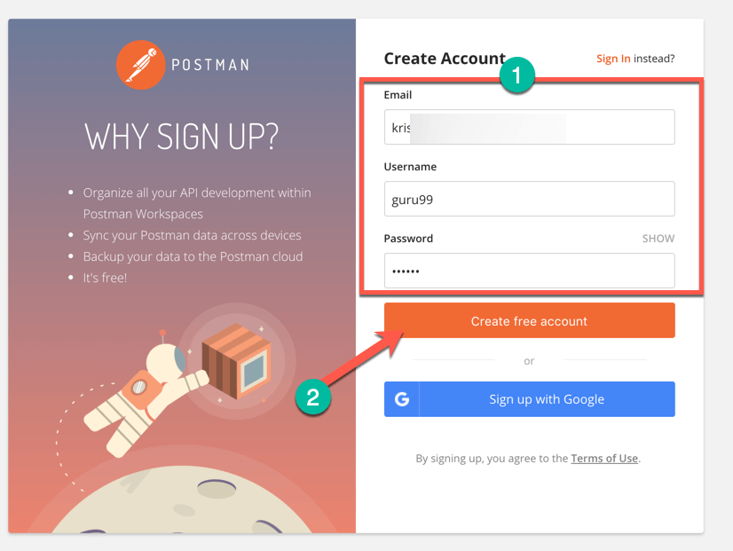

Select the required workspace tools

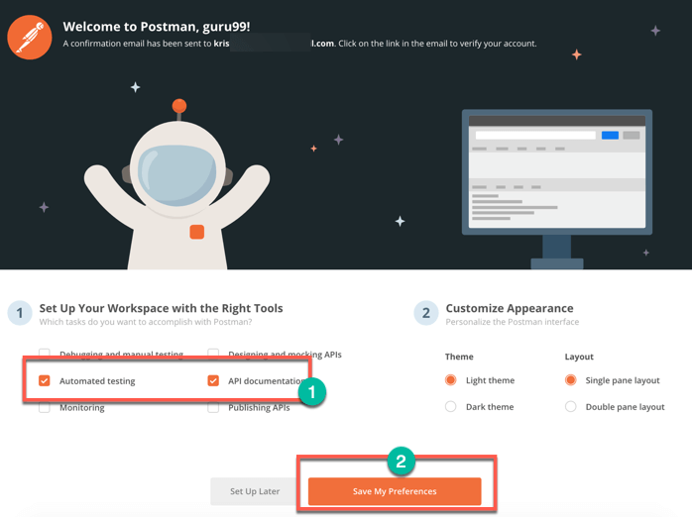

Now you will see a dashboard of postman where you can see workspaces, collections….

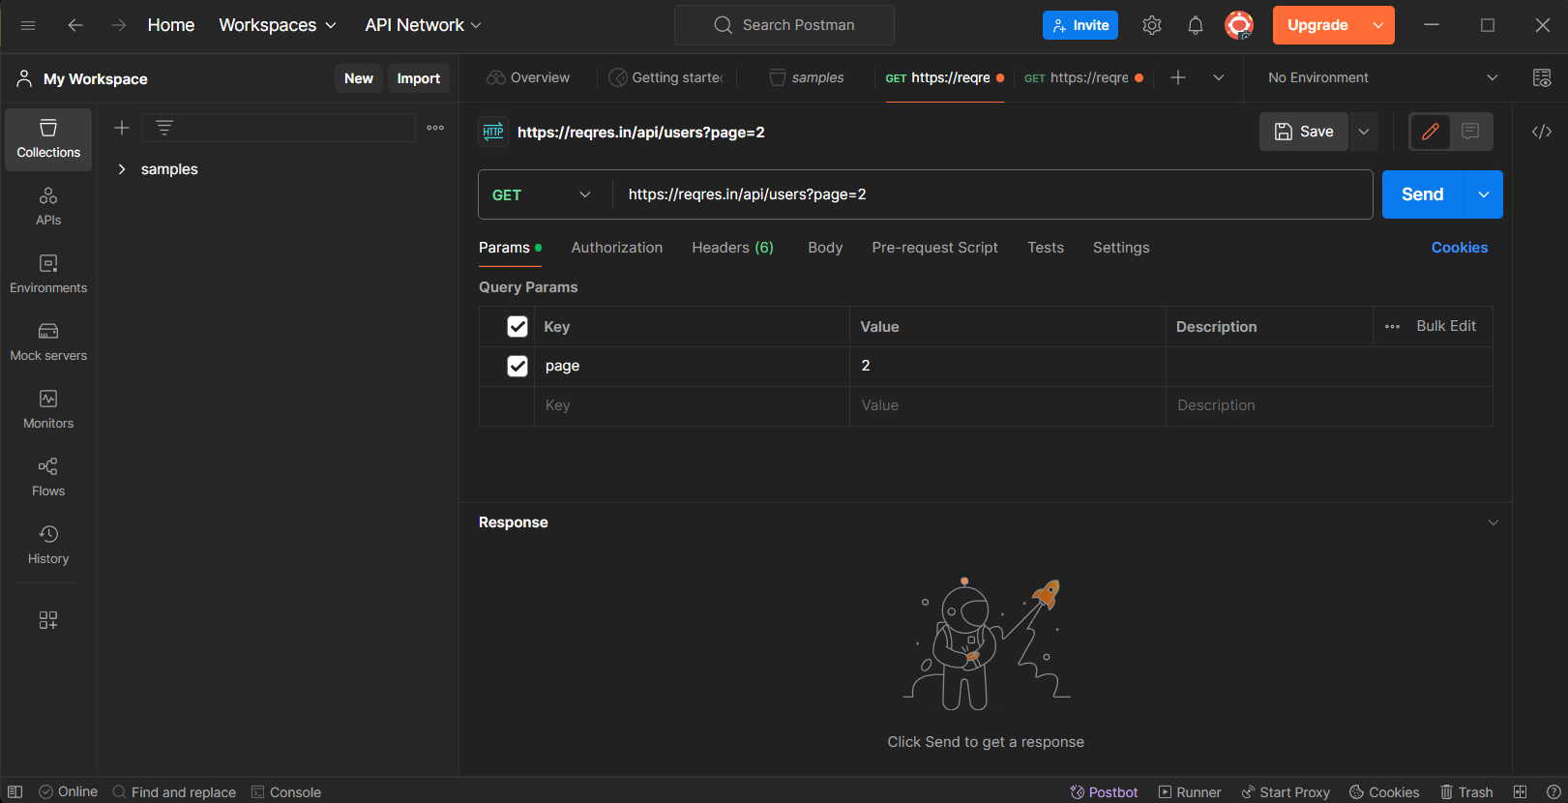

**First API request**

Create a new workspace

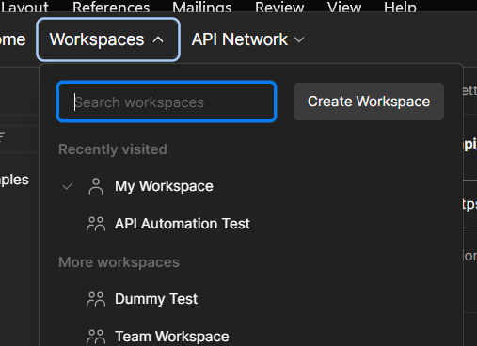

Click on new and select http to start a new request

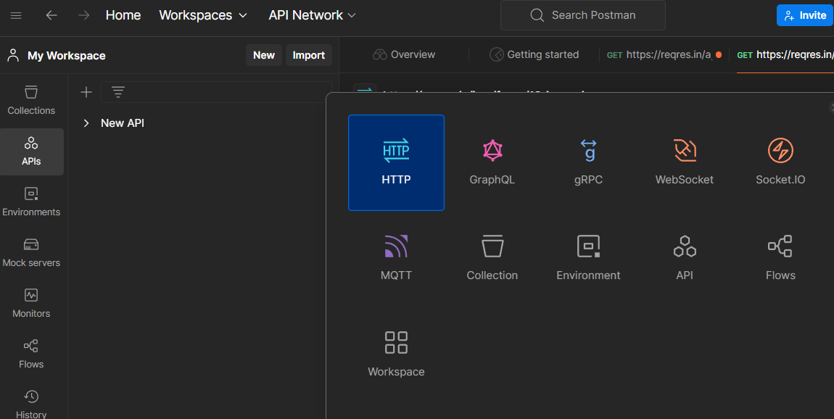

You will see a new request created add the below url and click on send. You will see a json as an output

<https://reqres.in/api/users?page=2>

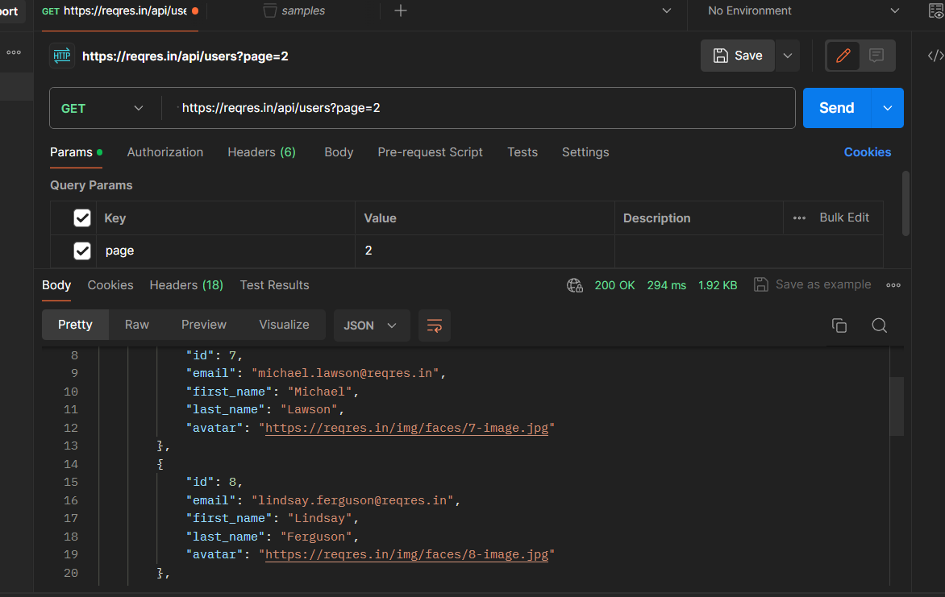

**Postman with SOAP**

Adding SOAP request with postman workspace

In the workspace create a new request.

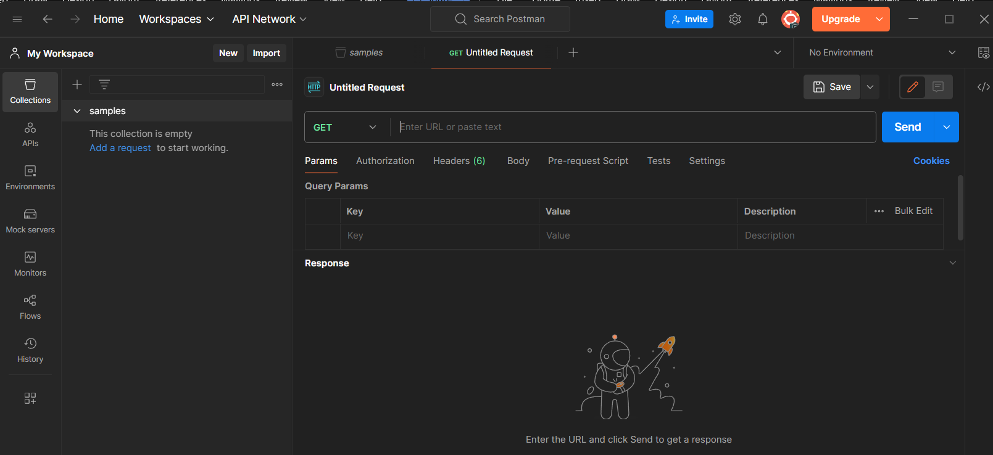

Paste the below url and set the method as post

<http://webservices.oorsprong.org/websamples.countryinfo/CountryInfoService.wso?WSDL>

Set body as raw and text as XML

Add the following code in the body section

<Envelope xmlns=”http://schemas.xmlsoap.org/soap/envelope”>

<Body>

<capitalcity xmlns=”http://www.oorsprong.org/websamples.countryinfo”>

<sCountryISOCode>IN</ sCountryISOCode >

</capitalcity>

</Body>

</Envelope>

Go to tests tab and click on status code: Code is 200

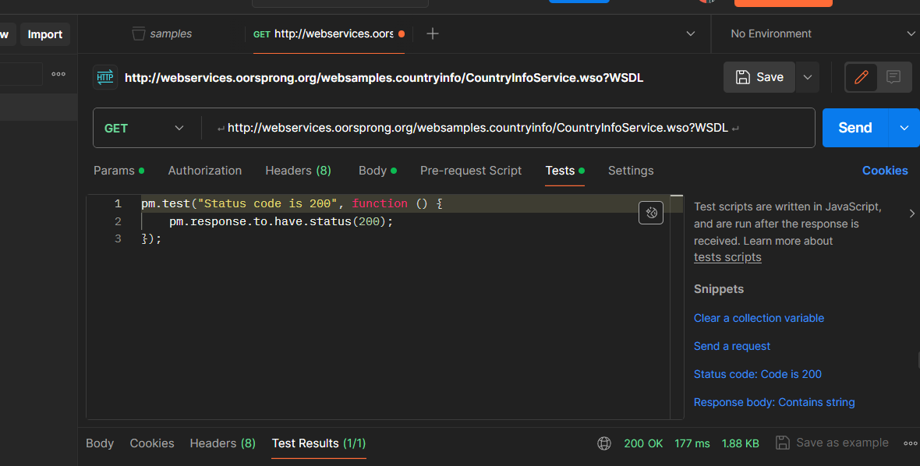

Click on send again then you will see test results as pass

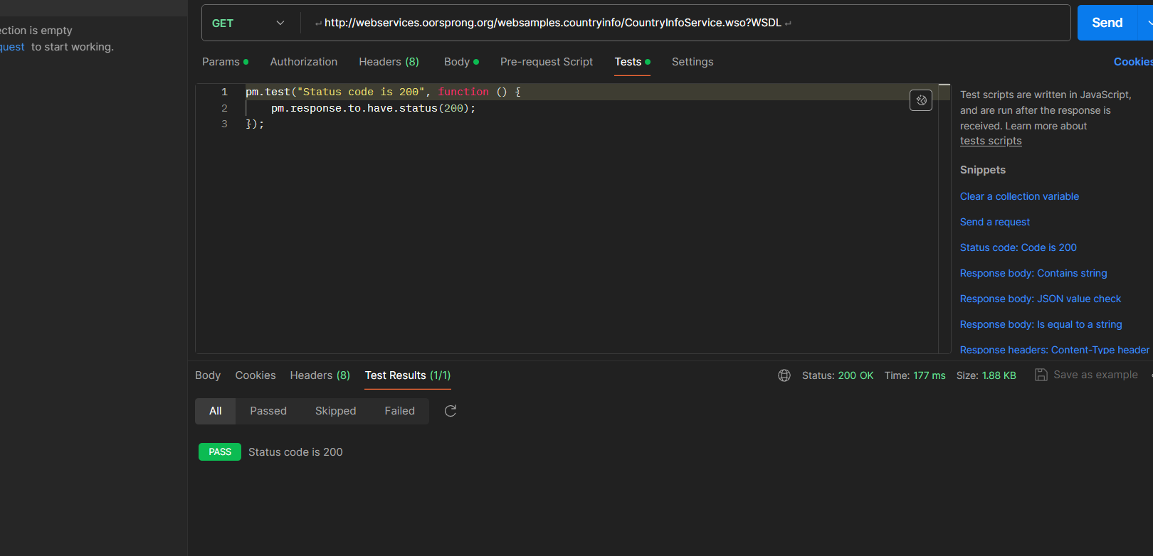

**Working with GET Requests**

Create a request in your workspace

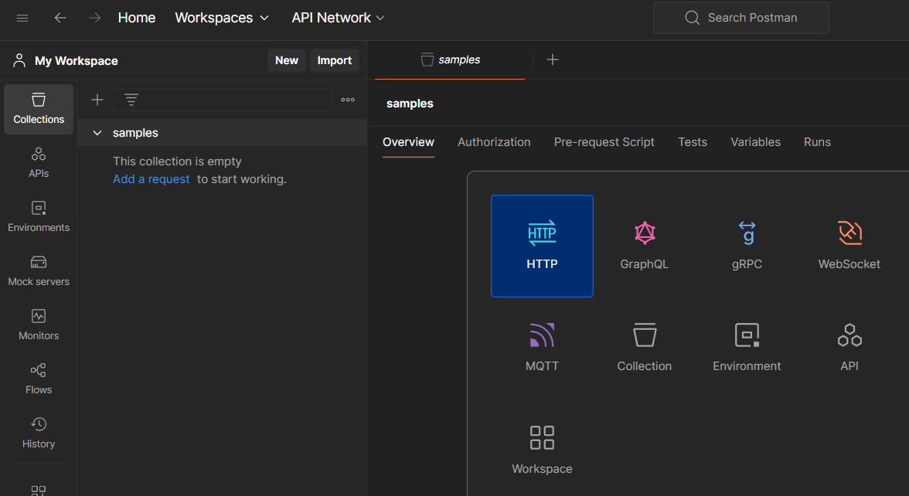

Let us take a sample url and click on send

[**https://reqres.in/api/users/2**](https://reqres.in/api/users/2)

set the request method as GET

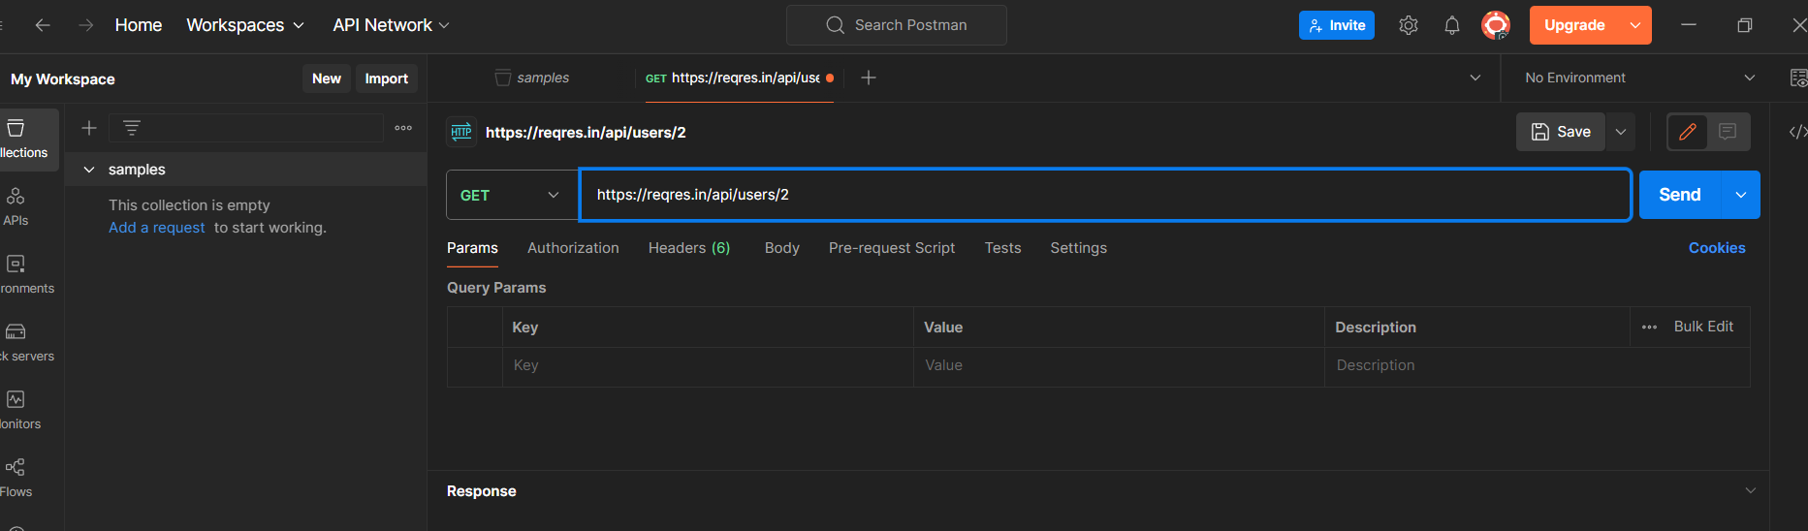

You will see a 200 OK message and a json output.

There may be cases where the Get request will be unsuccessful. It can be due to an invalid request URL or missing authentication.

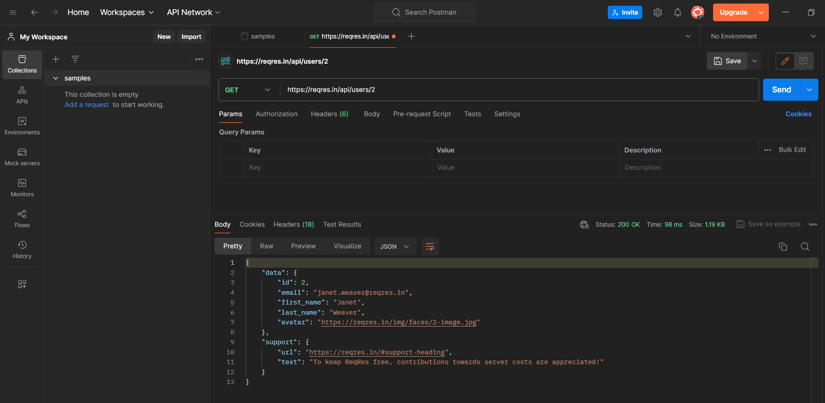

**Working with POST Requests**

Create a new request in your workspace

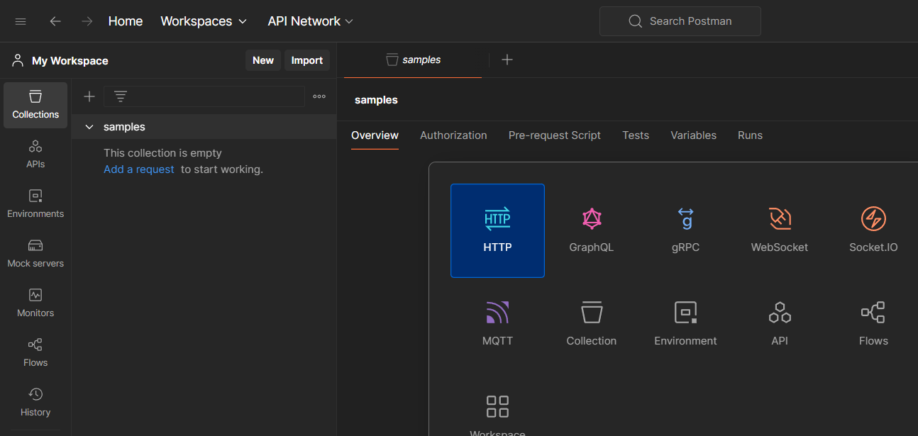

Let us take a sample url and use post method and click on send

<https://reqres.in/api/users>

under body tab add the json formatted details which we nee to add

{

"name": "morpheus",

"job": "leader",

"id": "463",

"createdAt": "2019-08-28T10:51:59.088Z"

}

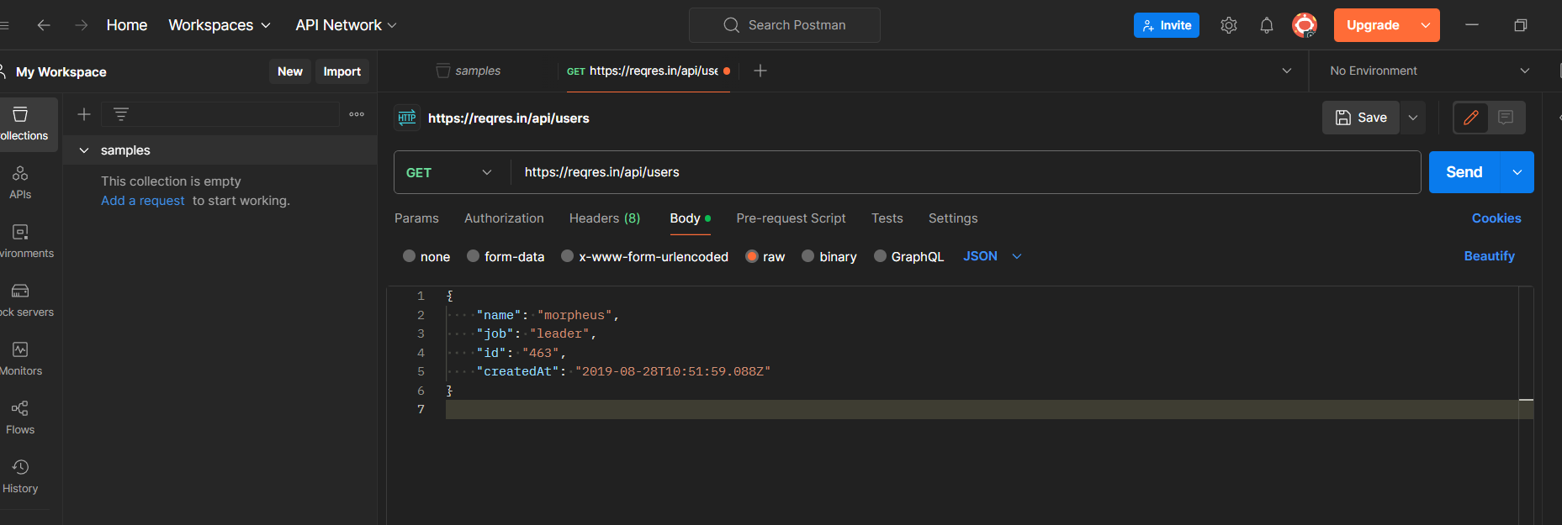

Click on send and you see the output as

201 created

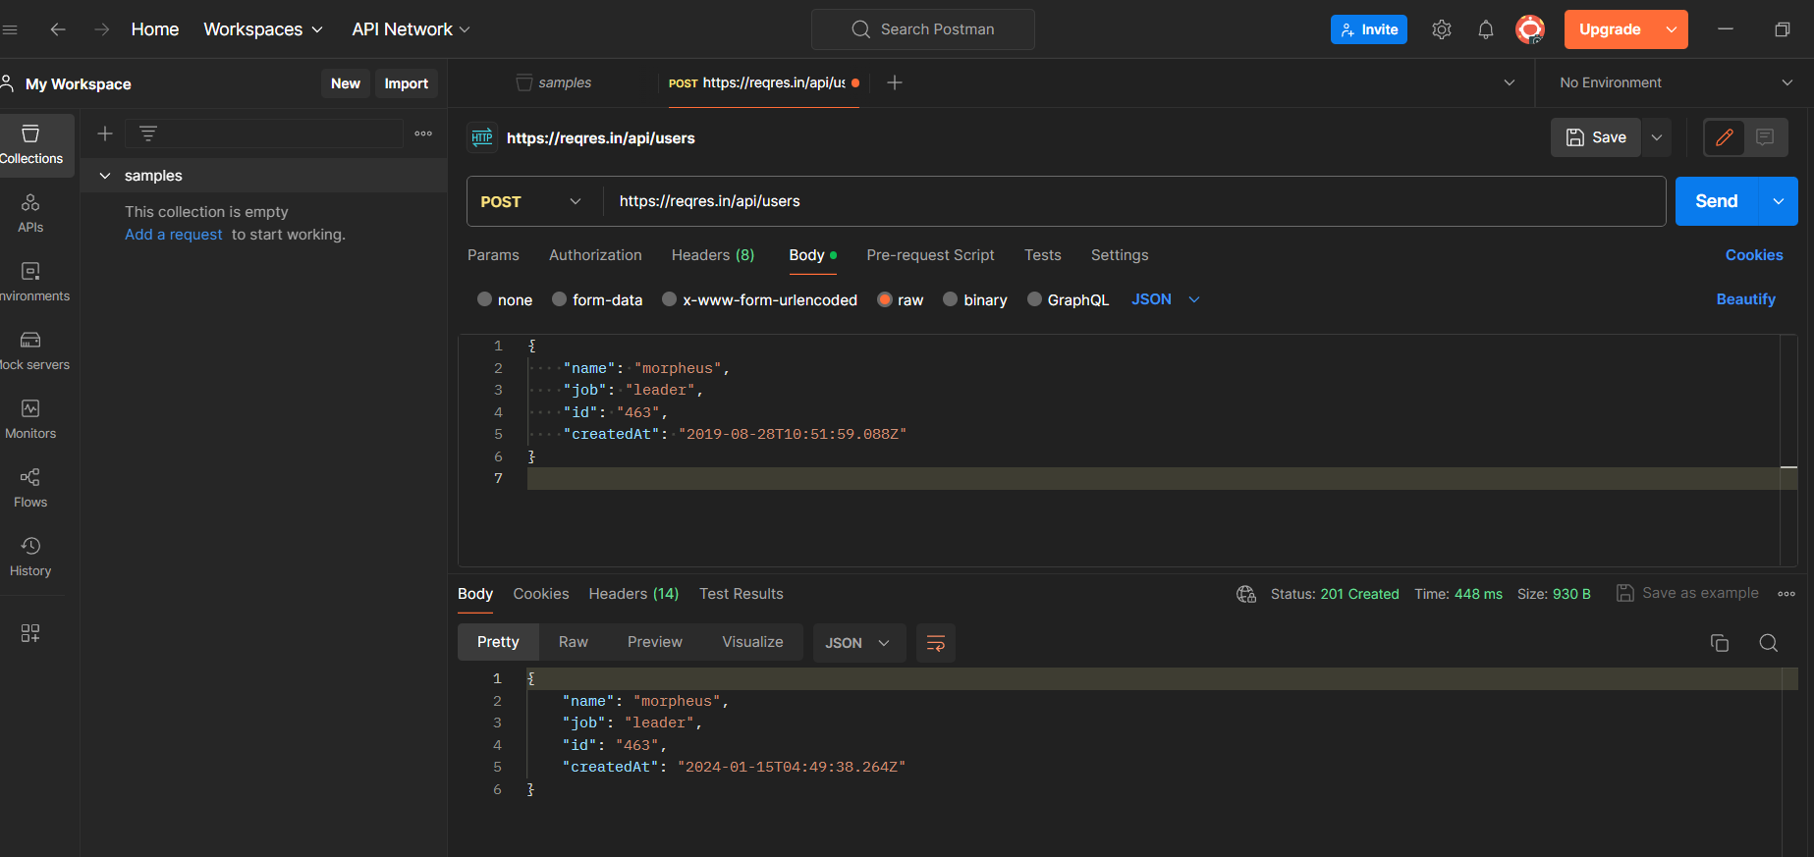

**Parameterize Requests**

Create a http request in your workspace

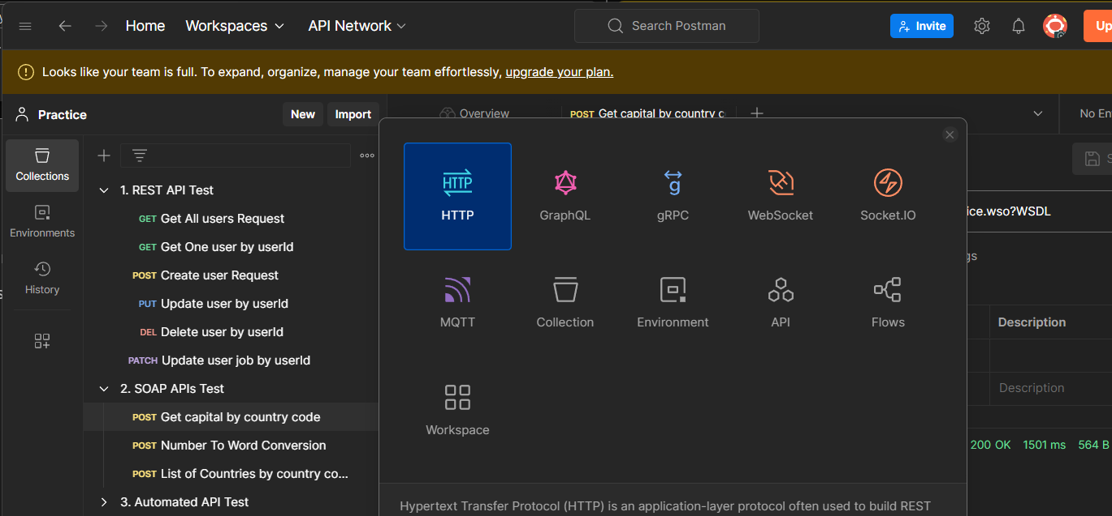

Let us take a sample url and set the method as GET

https://reqres.in/api/users?page=2

under environments section you can add global variables

create a variable with name URL and value as <https://reqres.in/api> and save it

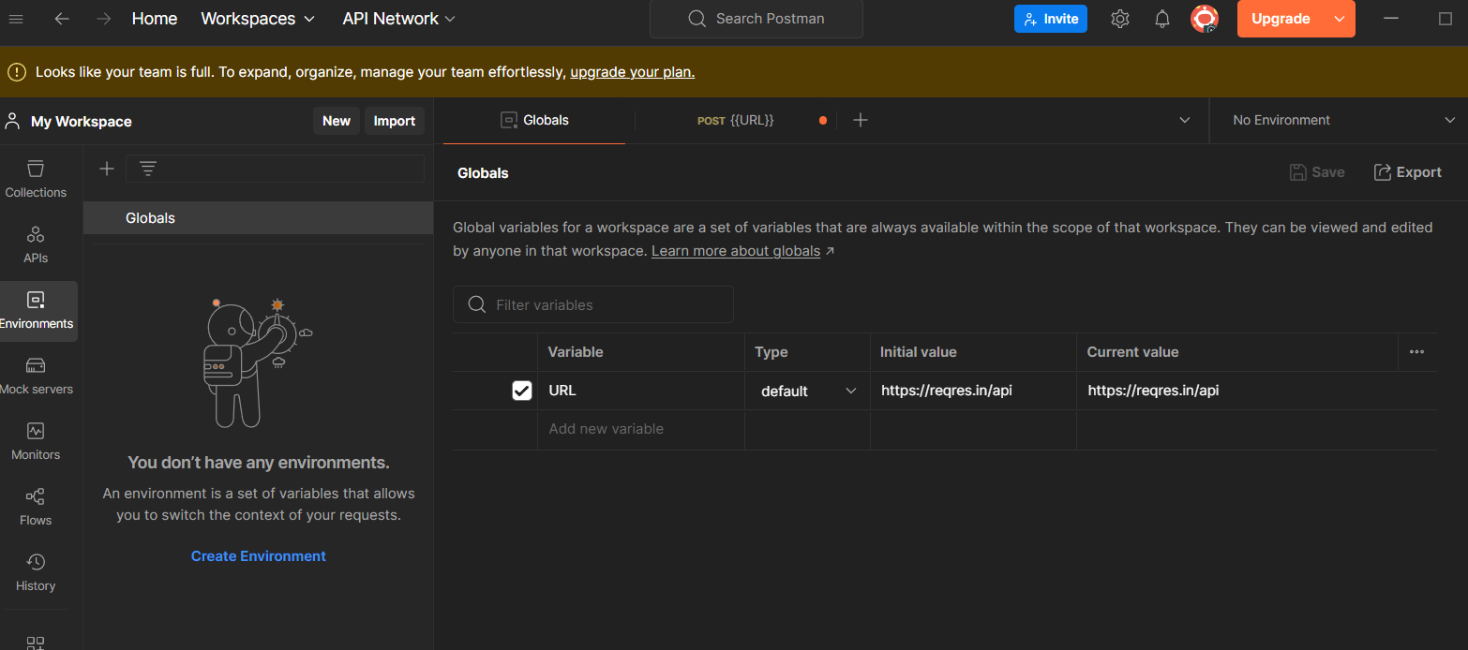

now you can use the url variable

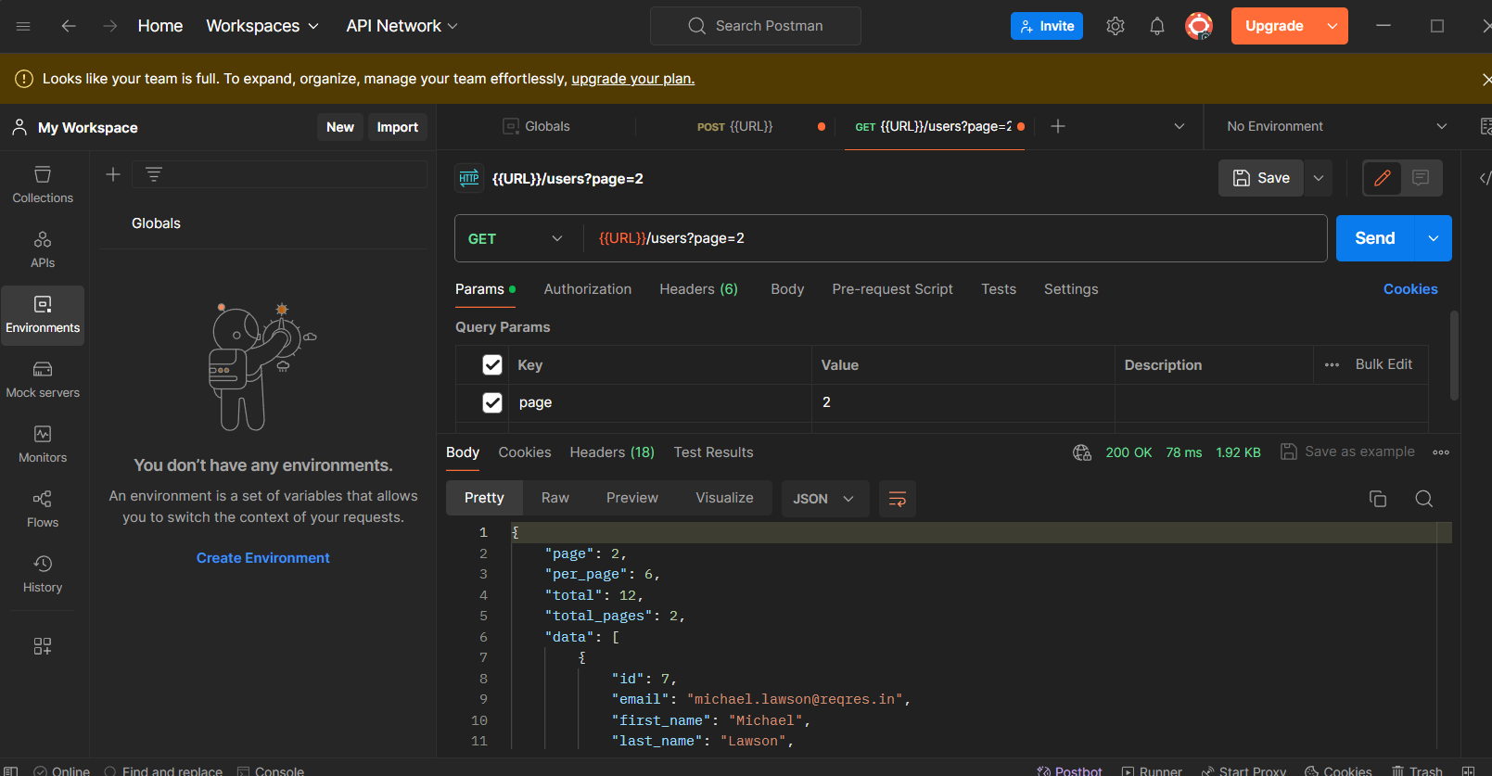

You can see the code as 200 OK and a JSON output

**Create a Collection**

Under the collections tab create a new collection

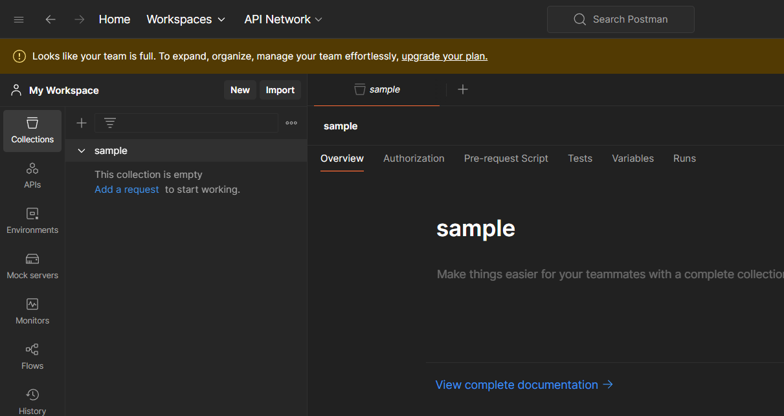

Now create a request using the three dots beside the collection name

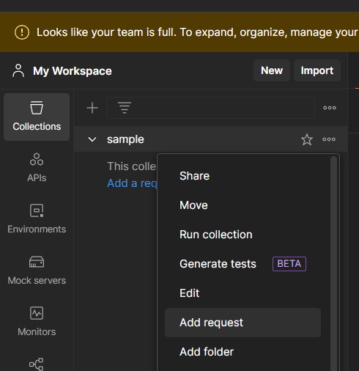

Add a sample url and click on send

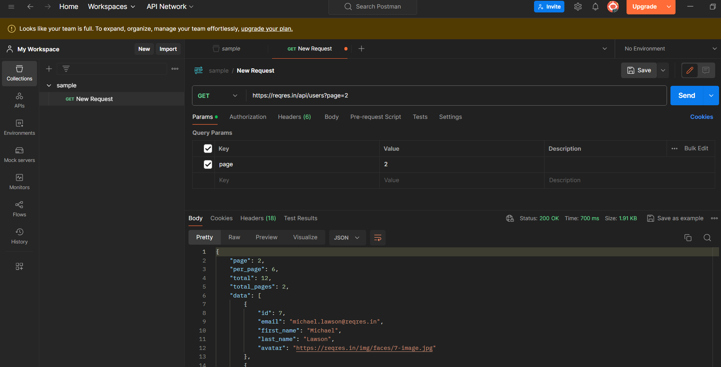

You run the collection by clicking the three dots and select run collection

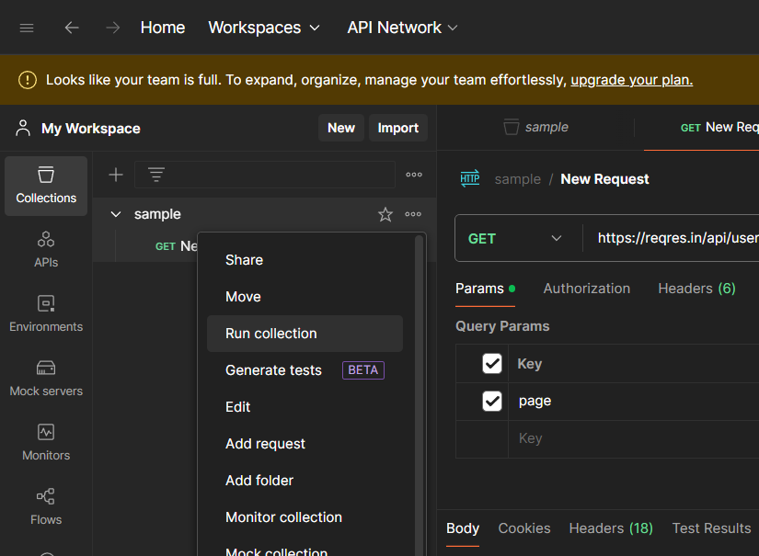

After you run the collection you will see the output as follows

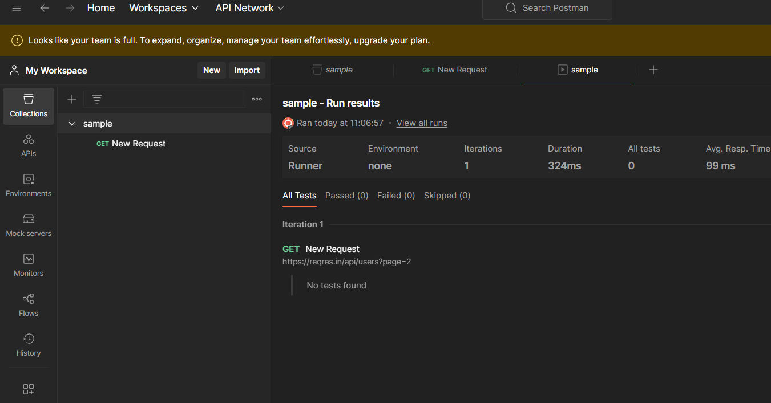

**Run collection with collection runner**

Let us run previous created collections using a runner

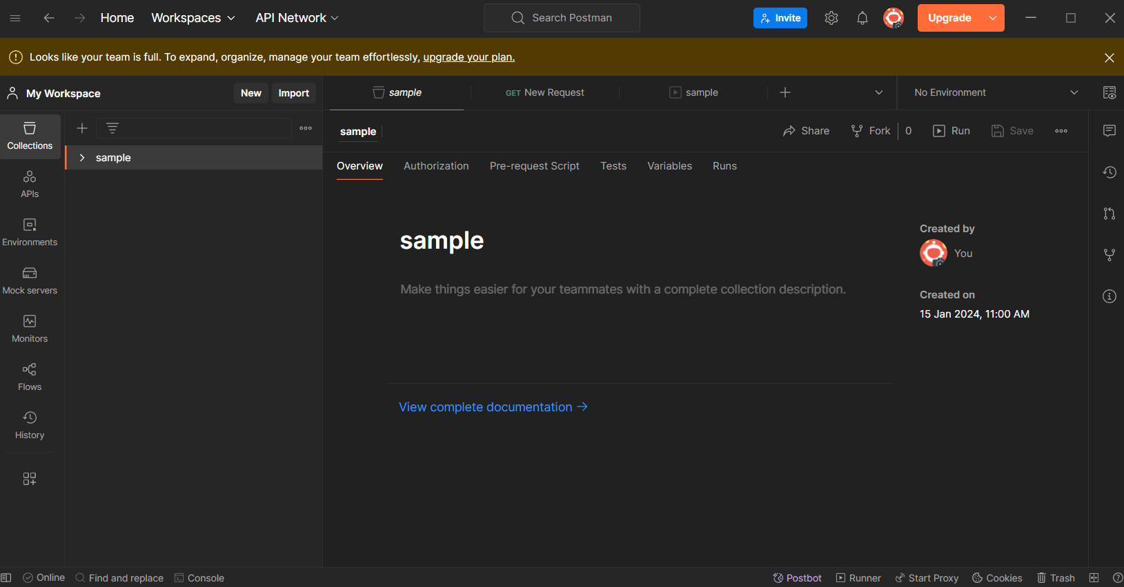

Click on runner. You can find it at bottom

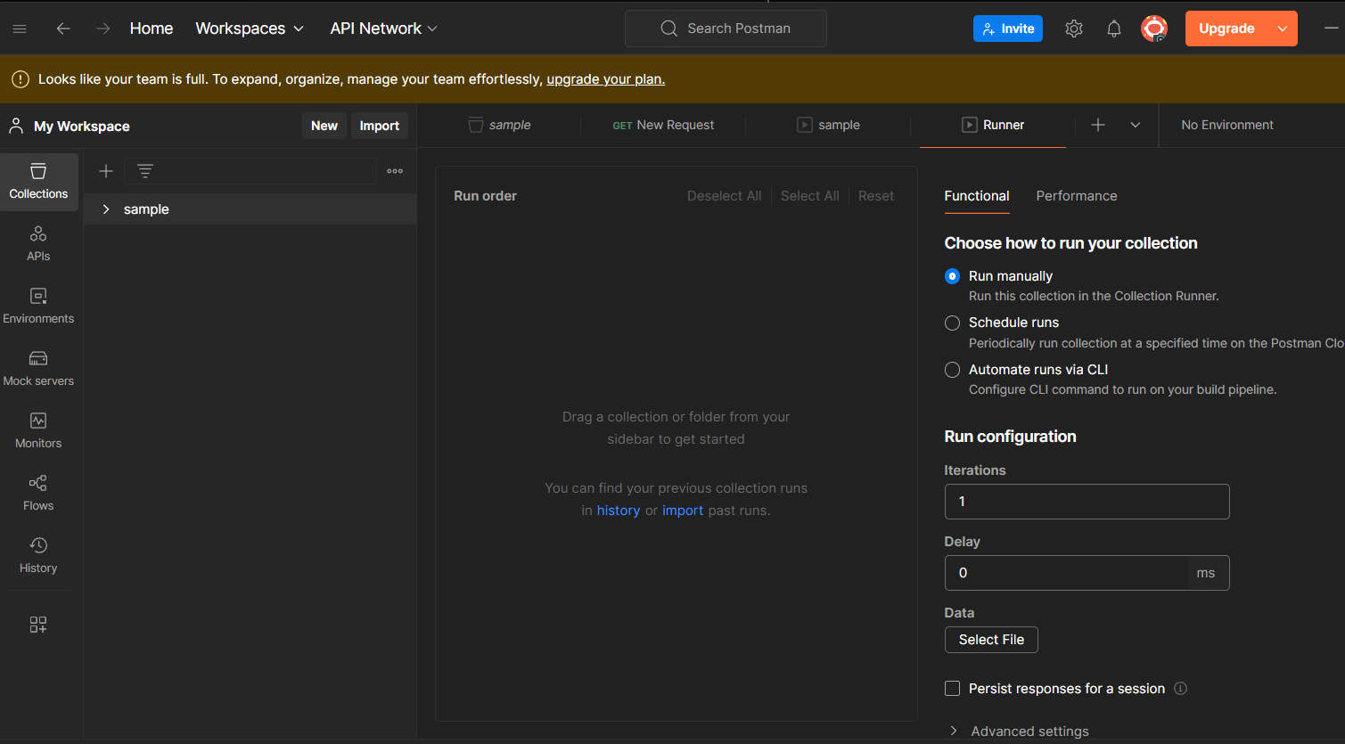

Drag the collection and click on run sample

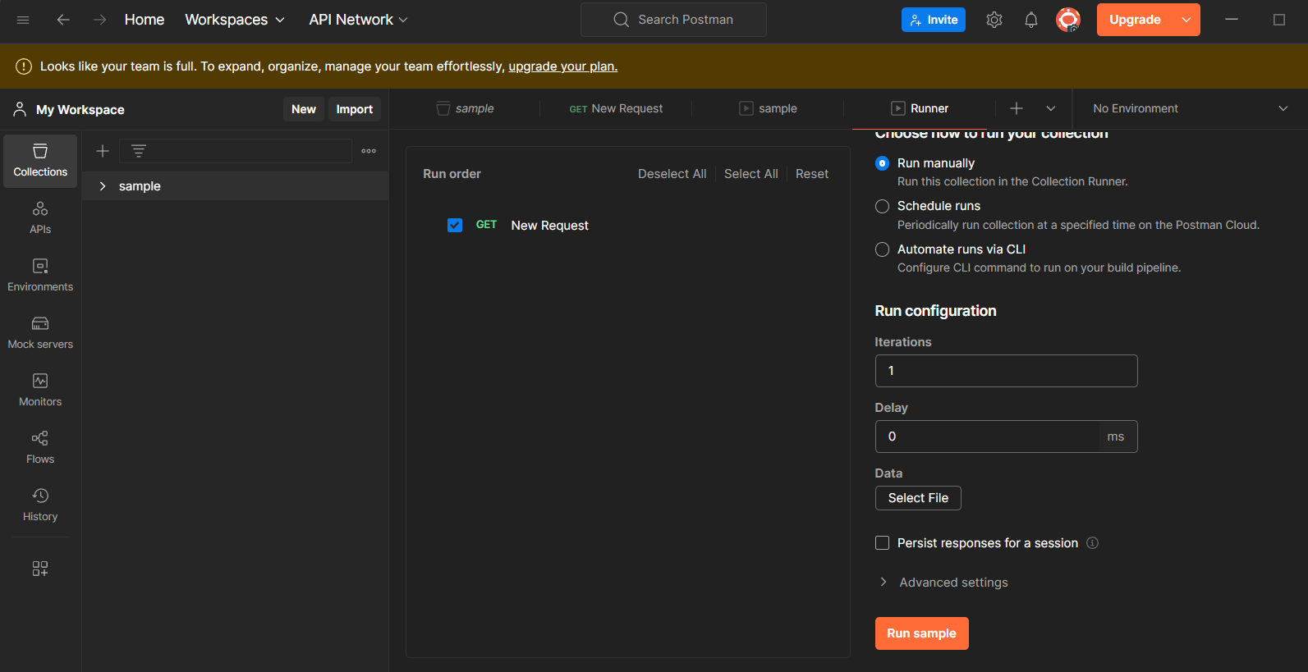

You will get the output as

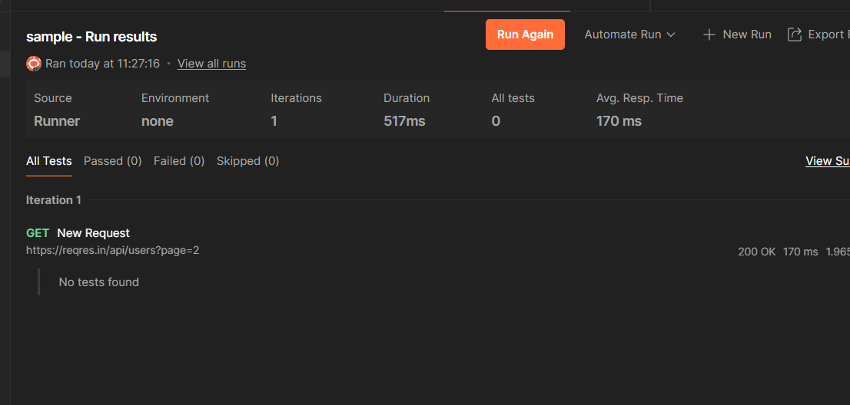

**Variables**

**Create a request in your workspace**

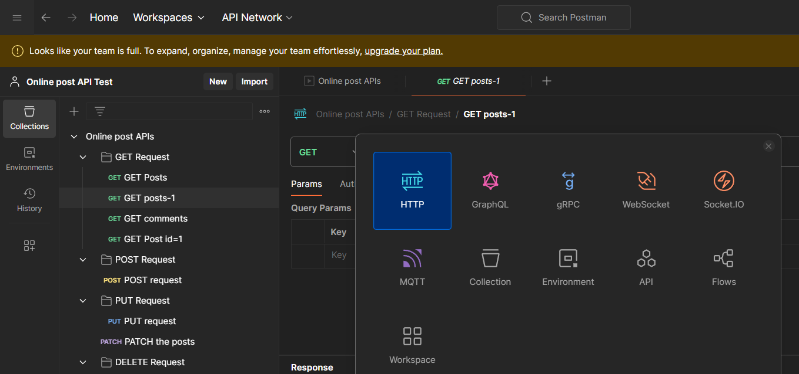

**Once you click on your collections. Got to variable tab and add a variable to it**

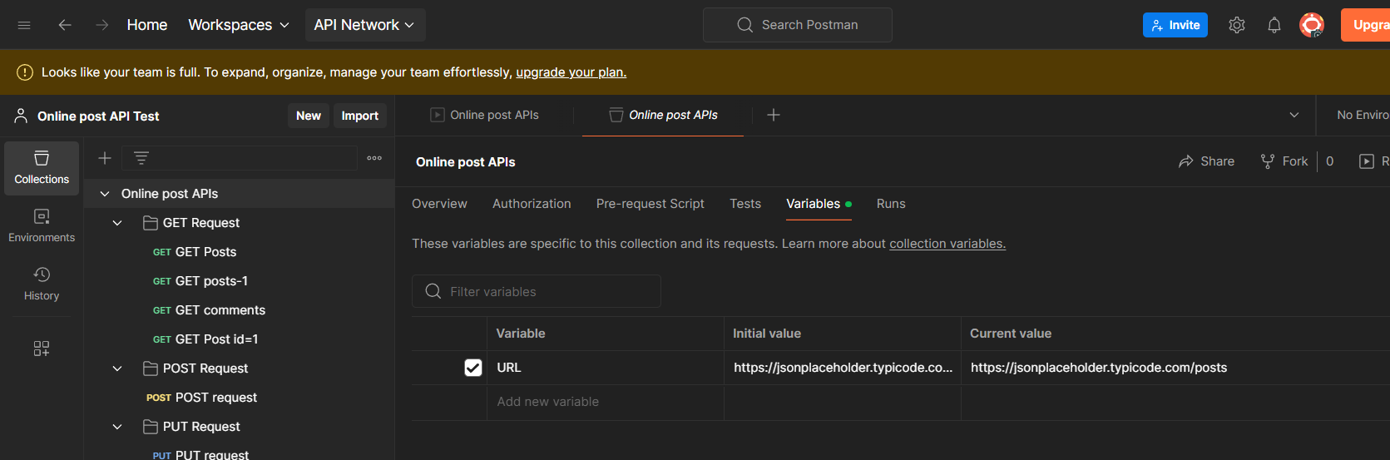

**Use the variable in the request and click send**

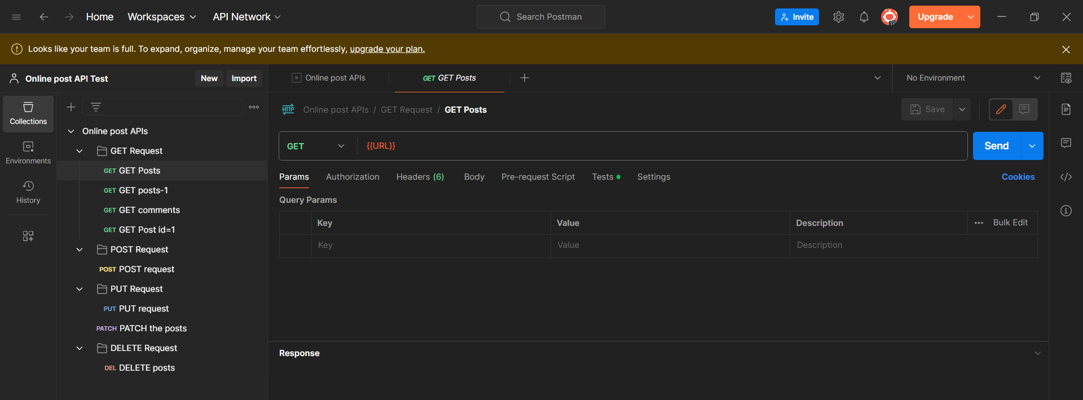

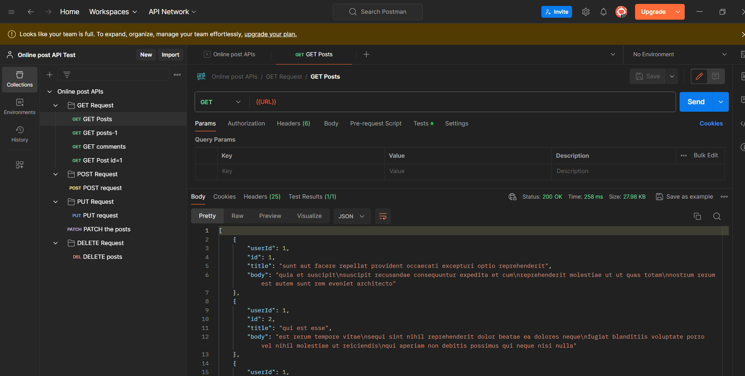

**You can see the result as 200 ok**

**Environments**

Environments are used to create variables

You can use different variables by creating different environments and using them

Create a request in your workspace

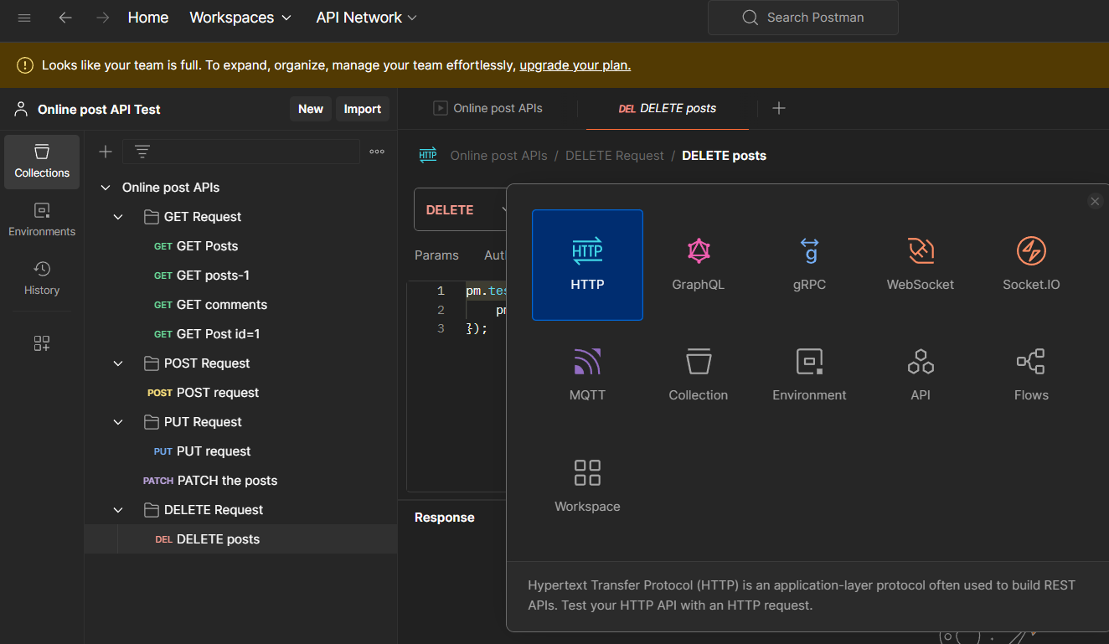

Create a new environment and create varables

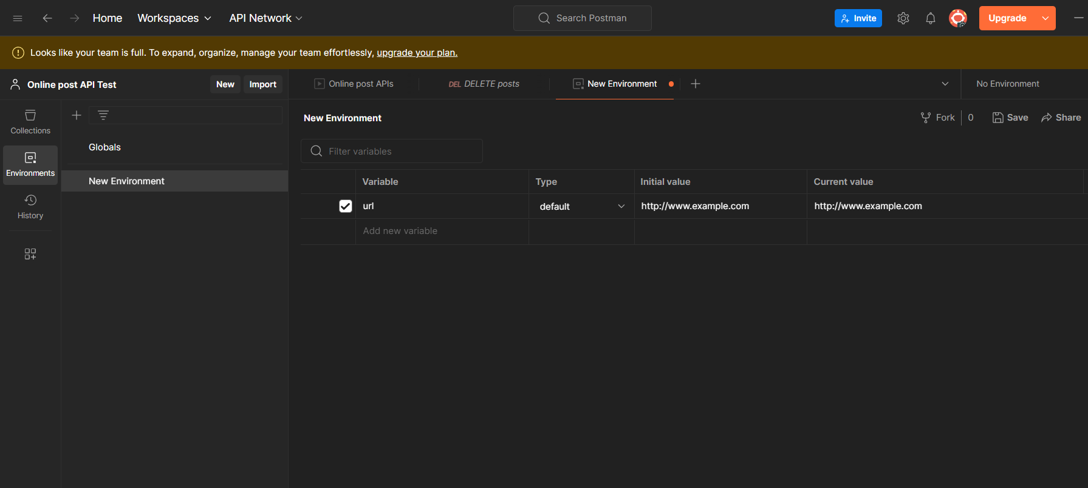

url variable is created in new environment

use the variable

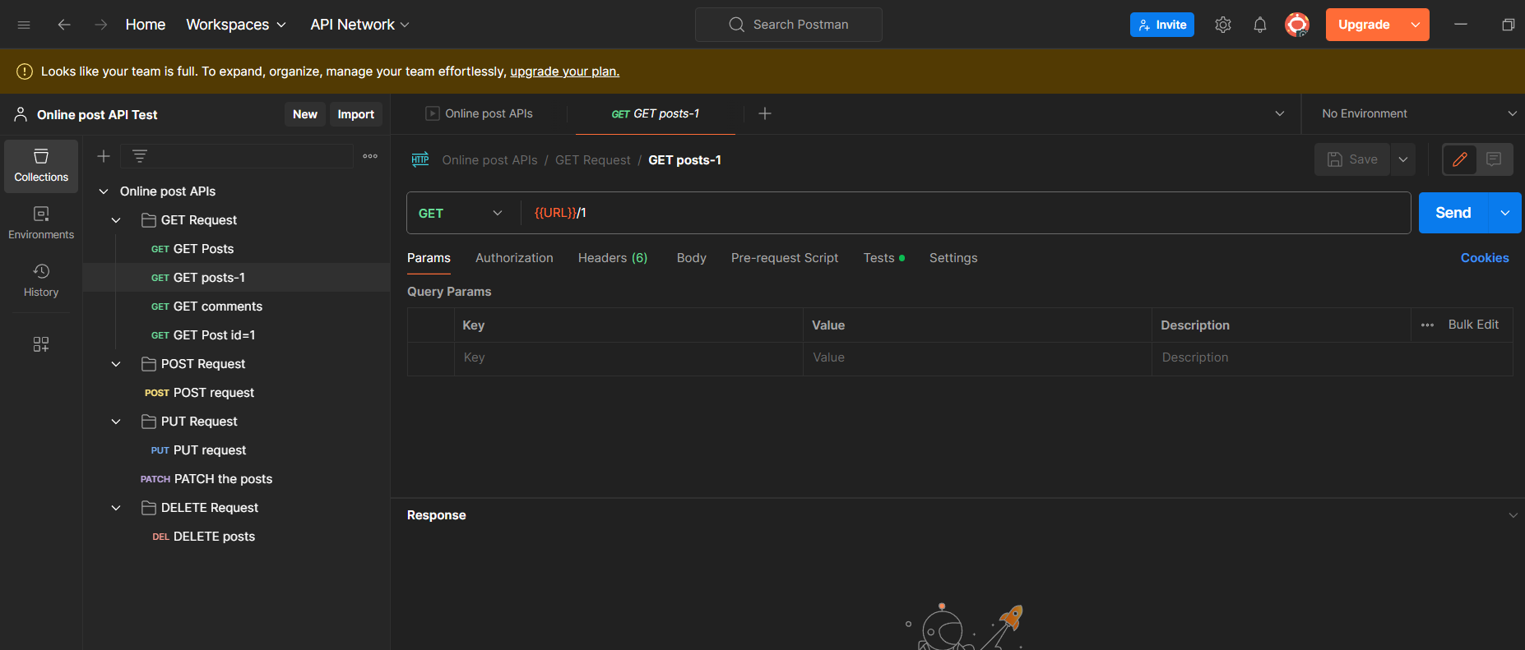

**Test Scripts**

Create a request in your workspace collection

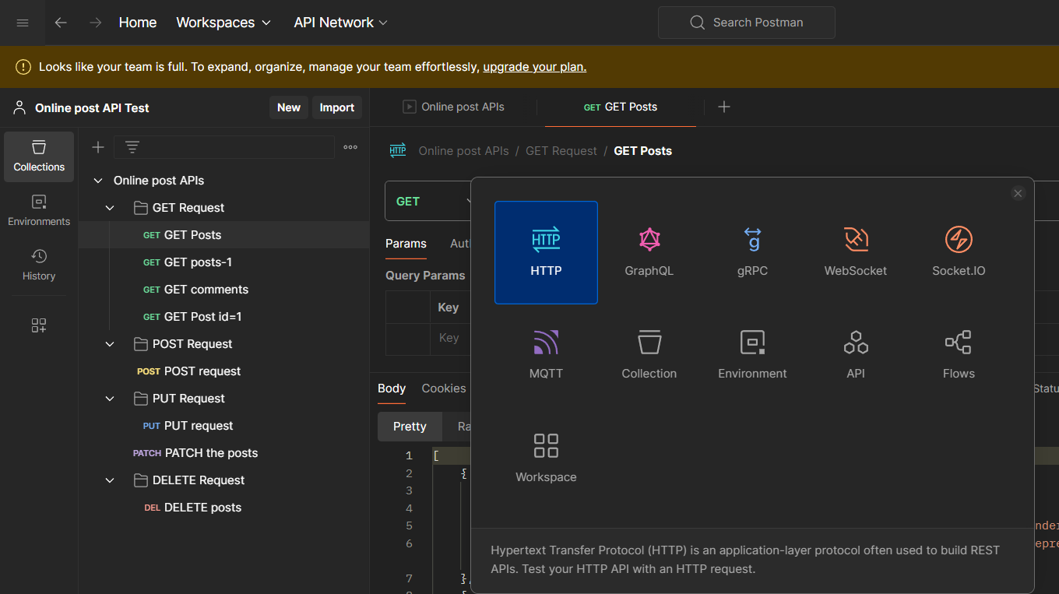

In your request got to the test tab and you can see some test snippets at right side

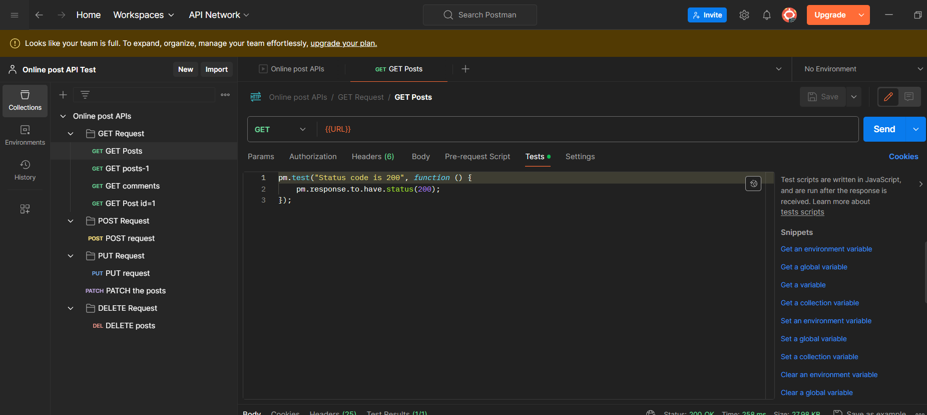click on status code :code is 200. So that a new test will be created for you

Now click on send

A new test result will be displayed

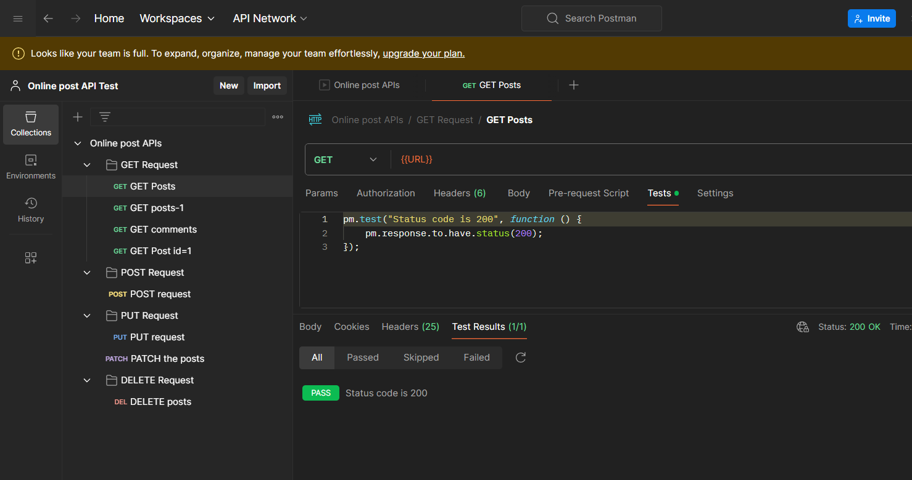

**Postman with Jenkins**

Open Jenkins and create a project

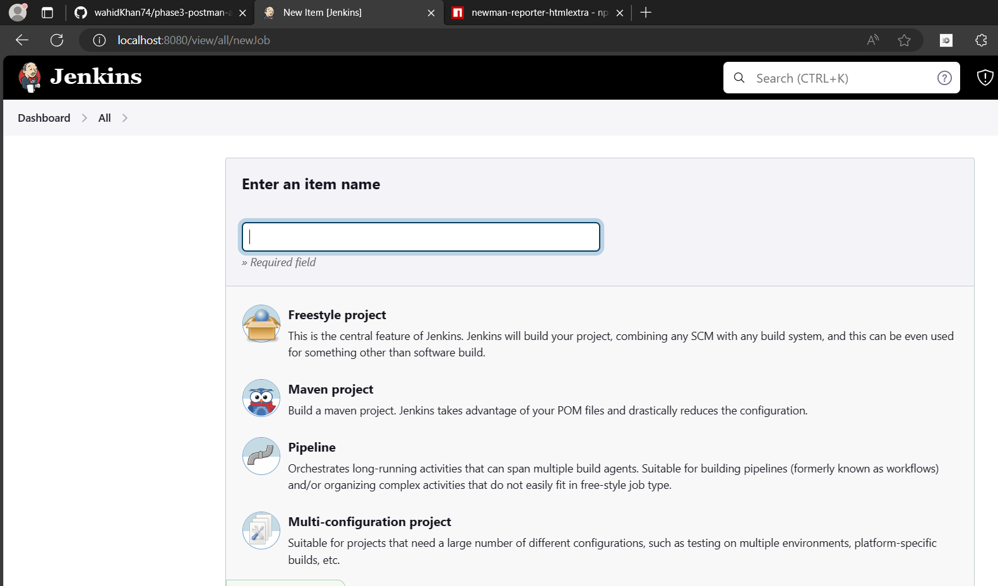

Insrall nodejs plugin

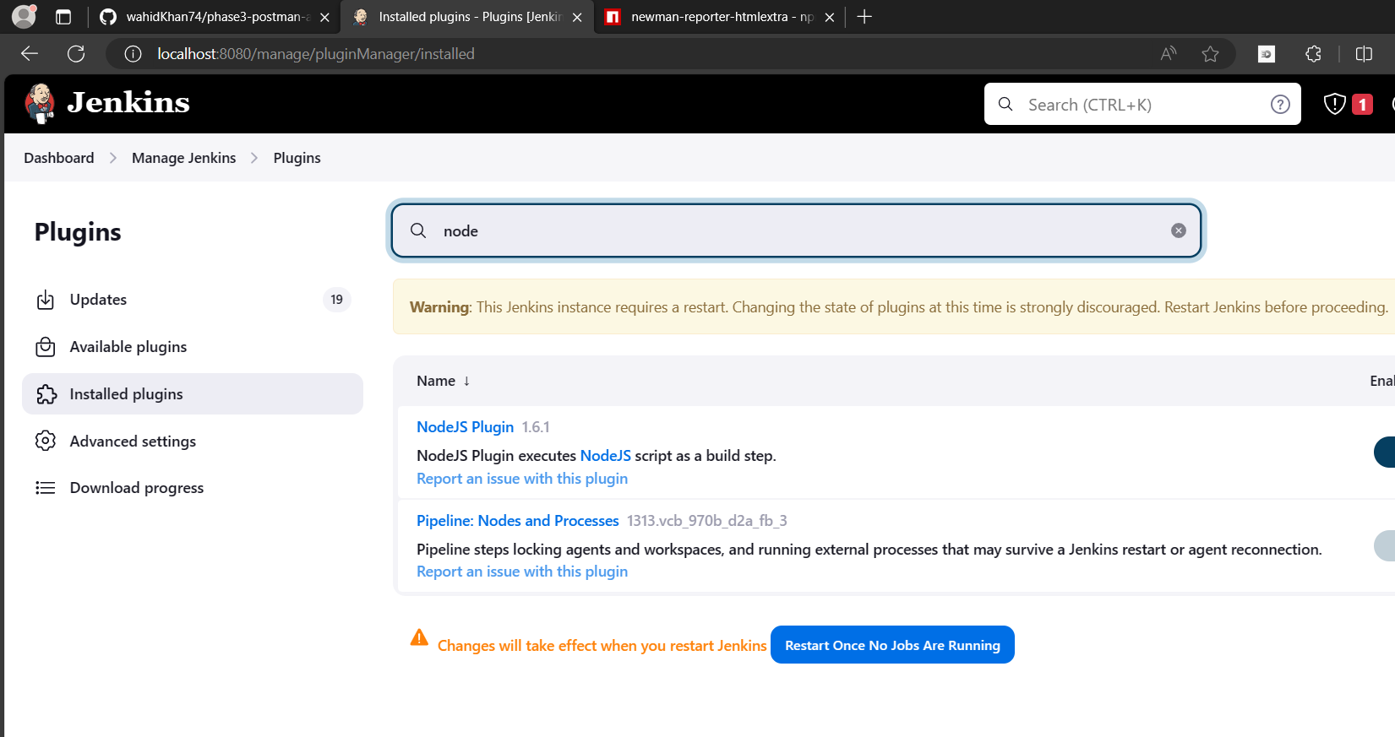

Push the postman files to github

Add github to your Jenkins project

Add nodejs installation

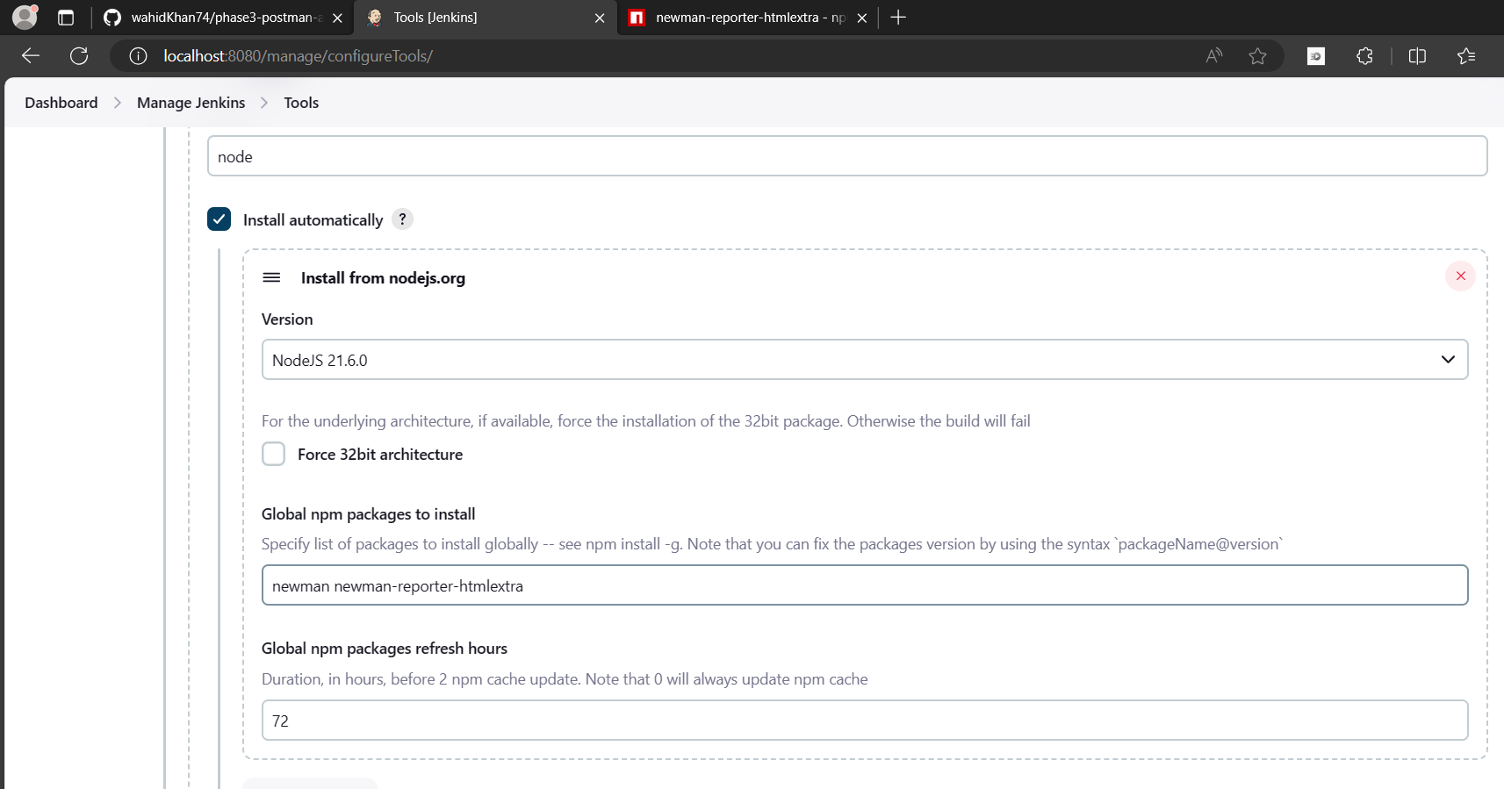

Under build environment add nodejs path

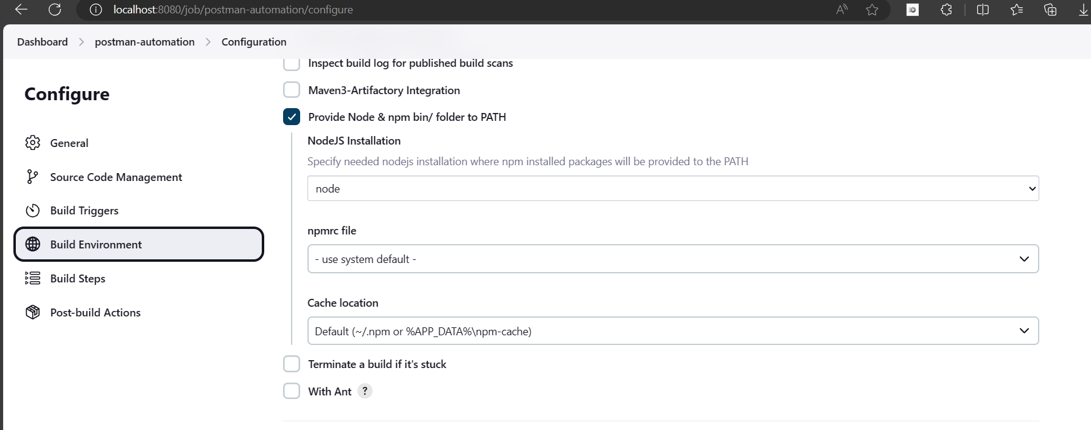

In build steps add windows batch command

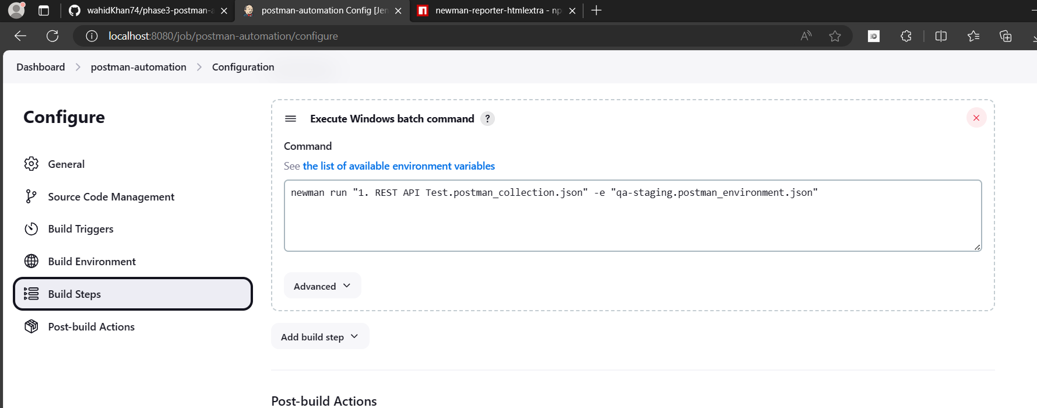

Click on build now and you can see the output

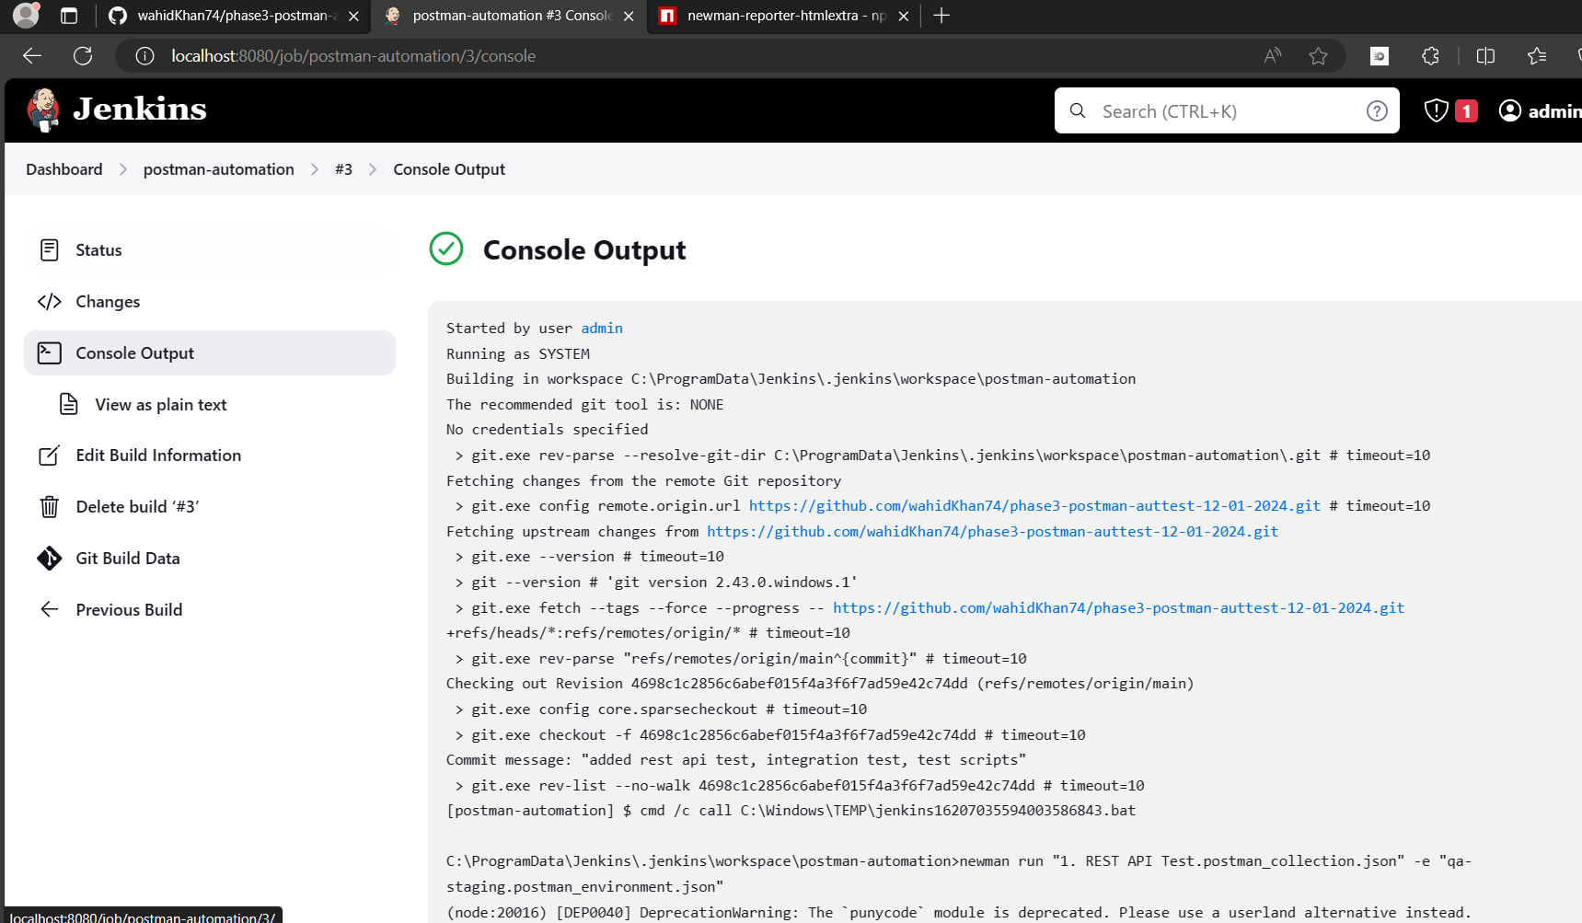

**Workspaces**

Work spaces in postman are used create multiple collections

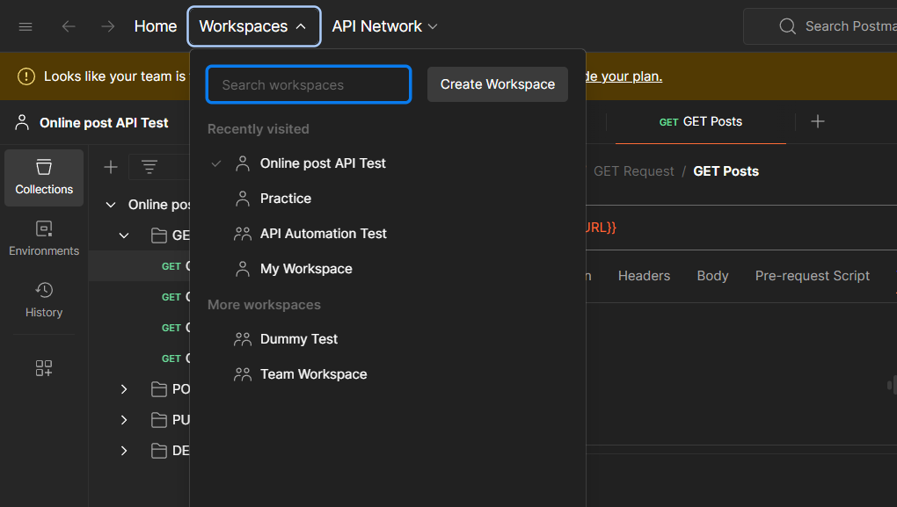

You can create multiple workspaces for different projects

Click on create workspace. Select what type of workspace you wish to create

And add name and description to it. Click on create

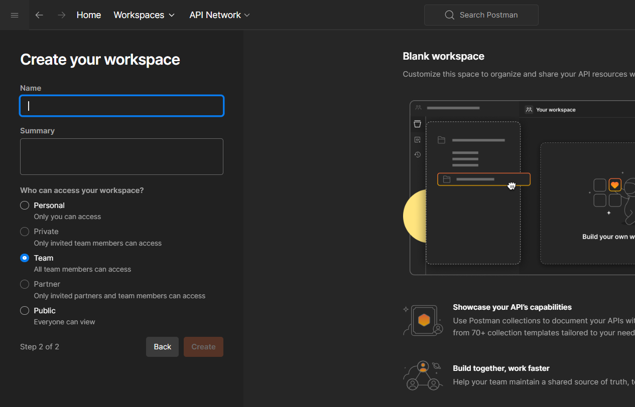

**Monitors**

Monitors in postman are used to monitor the collections in a workspace

To create a monitor click on three dots beside the collection name

And click on collection monitor

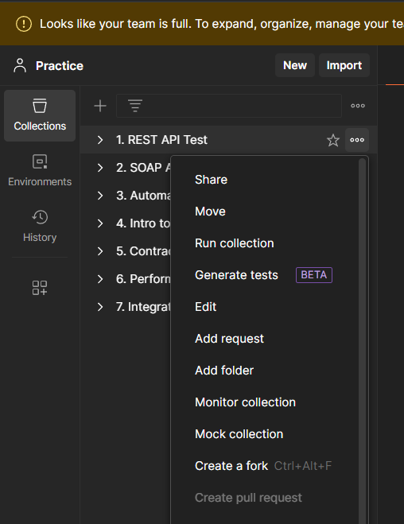

Add a name and click on create a monitor

Now the tests run everyday or for the time specified by you and display the result as healthy or unhealthy and the details of the run

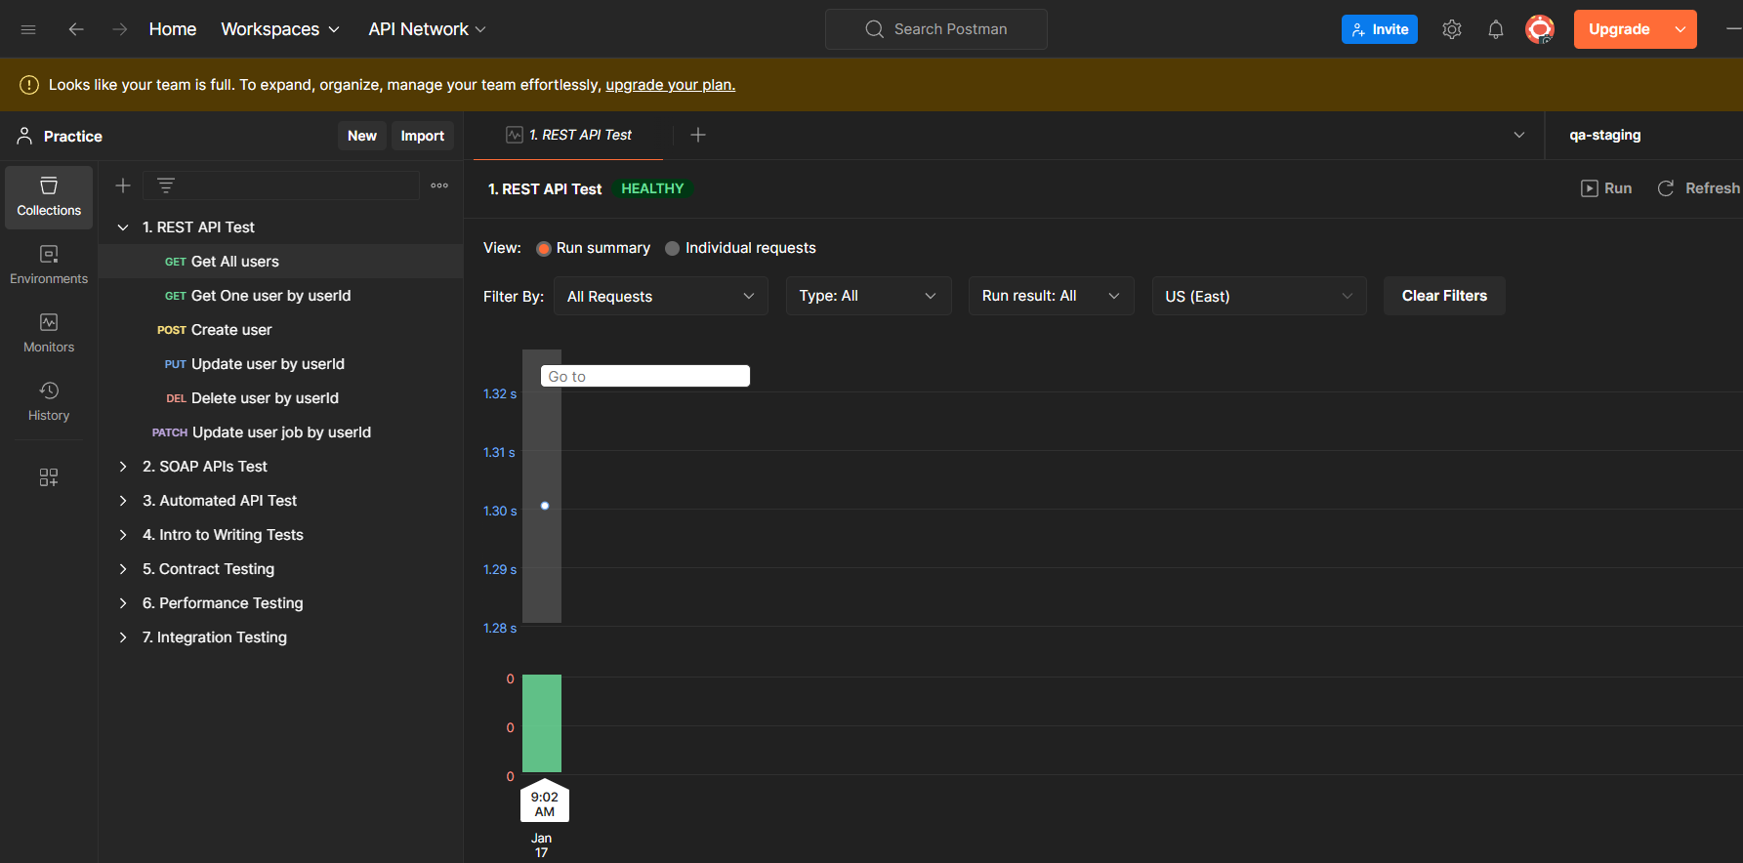

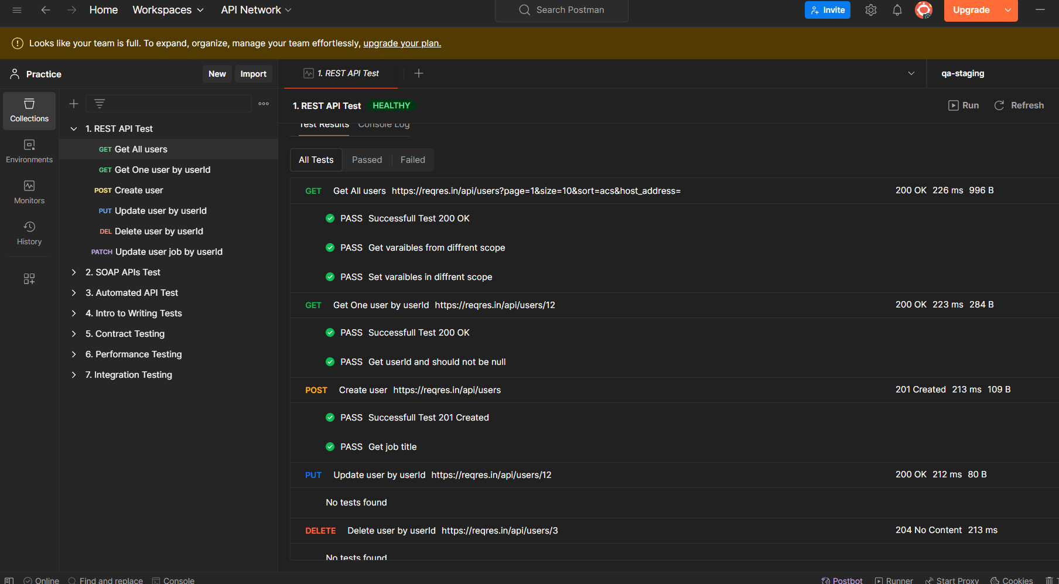

**API Documentation**

**Documentation helps you to understand the collections and the requests in detail**

**Click on the collection name in collection tab**

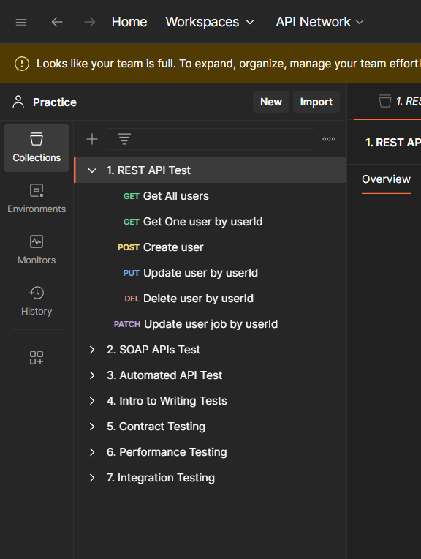

**Then you can see the overview of the collection which is a document**

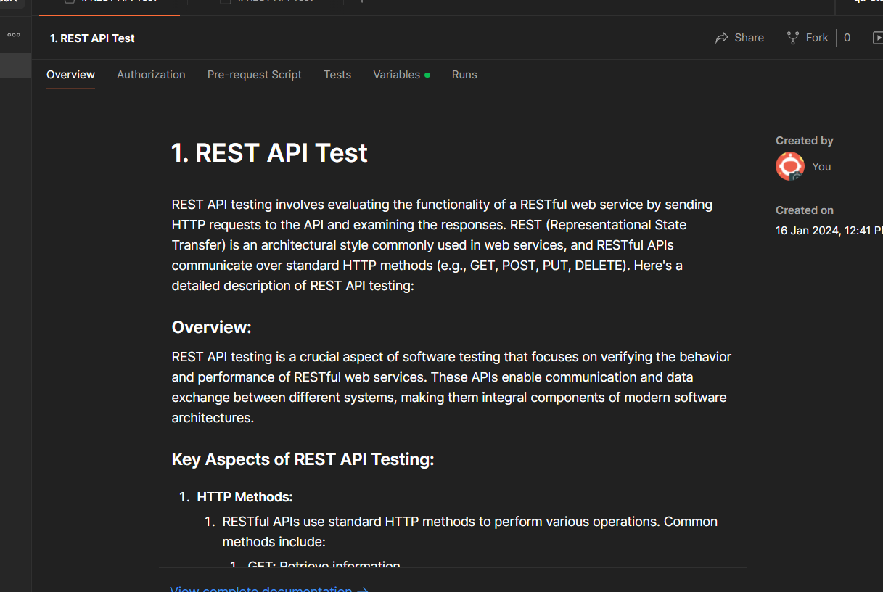

**If you want to edit the documentation double click and start editing**

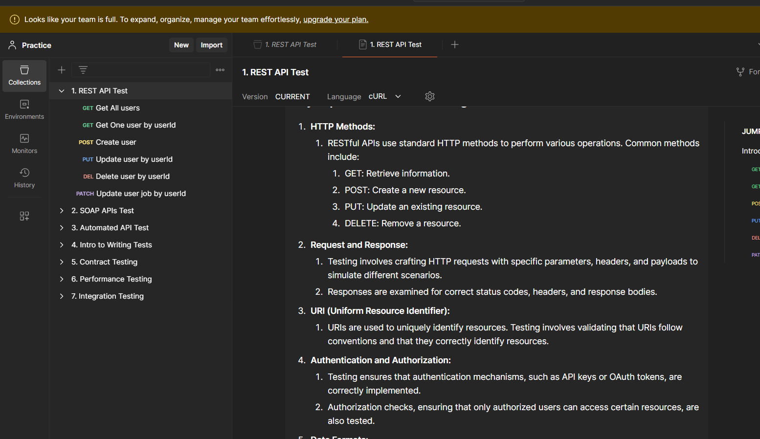

**Fetch data from csv and json**

Add data in notepad and name it as .csv file

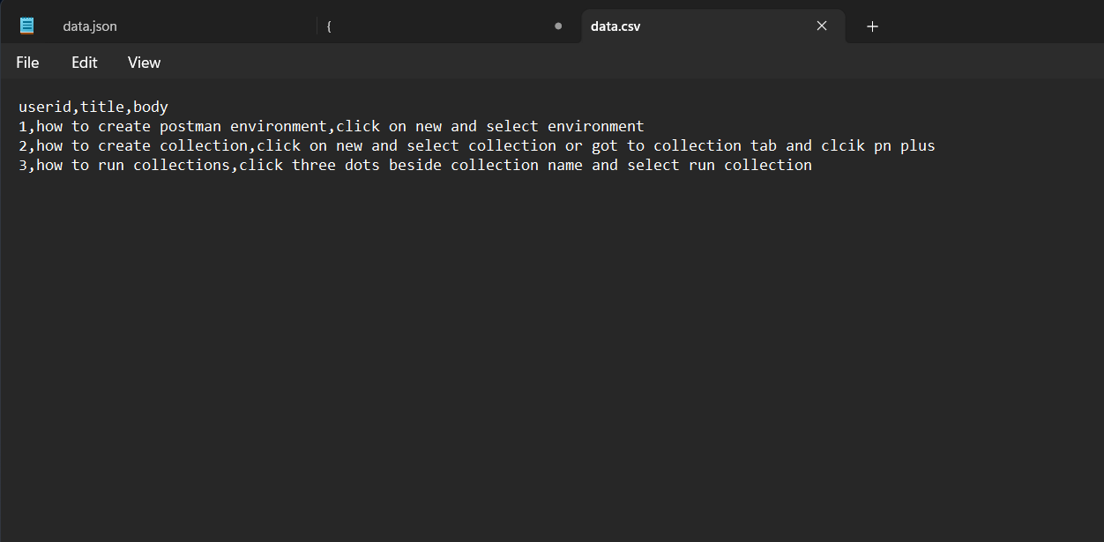

Create a request in the collection

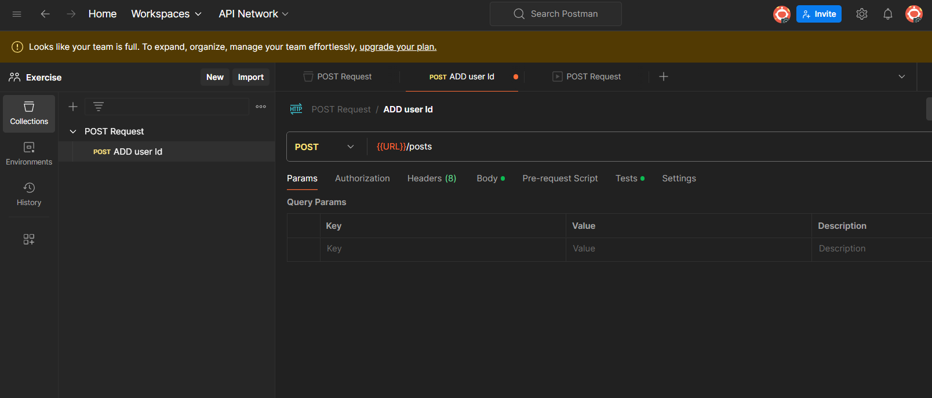

Run the request using collection runner

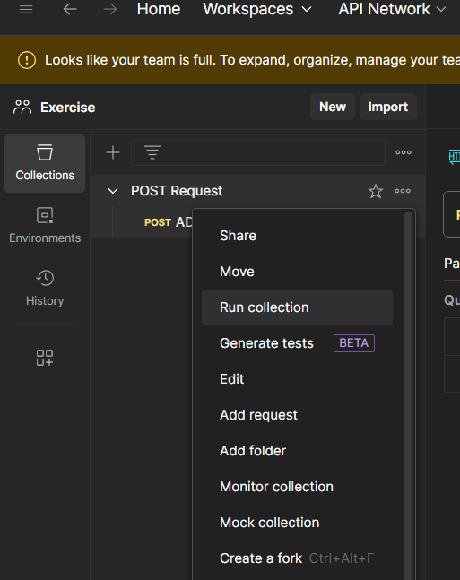

And select the csv file, click on run post request

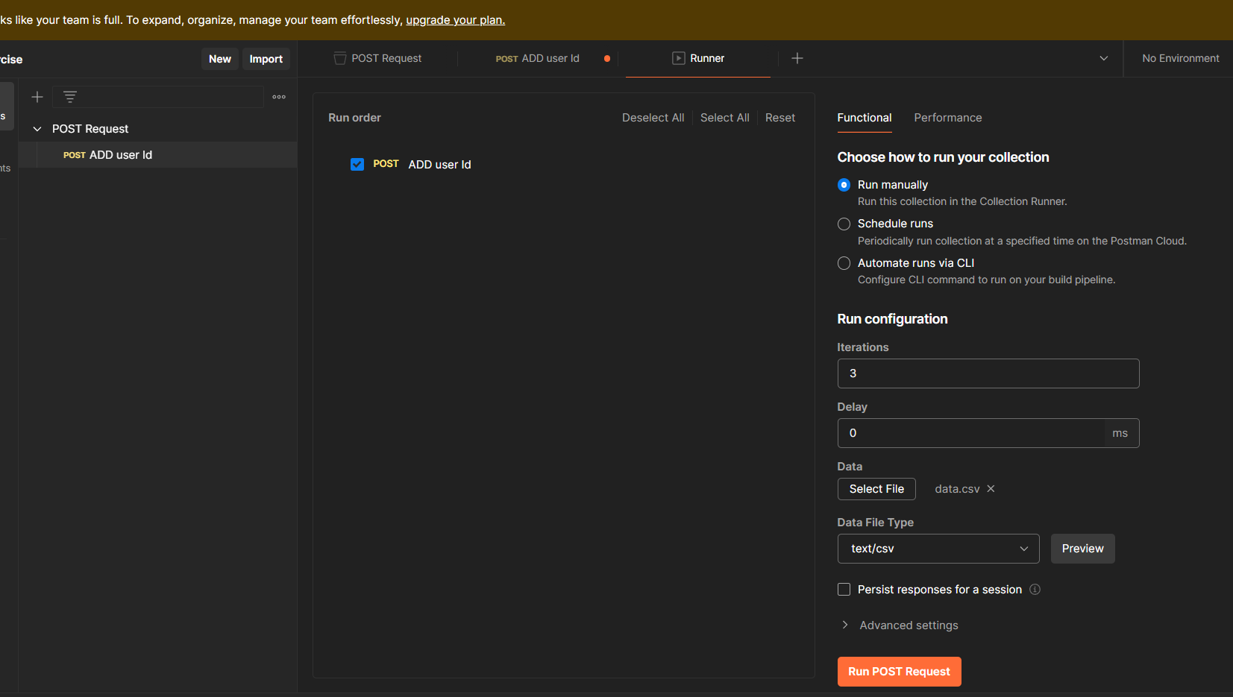

Result

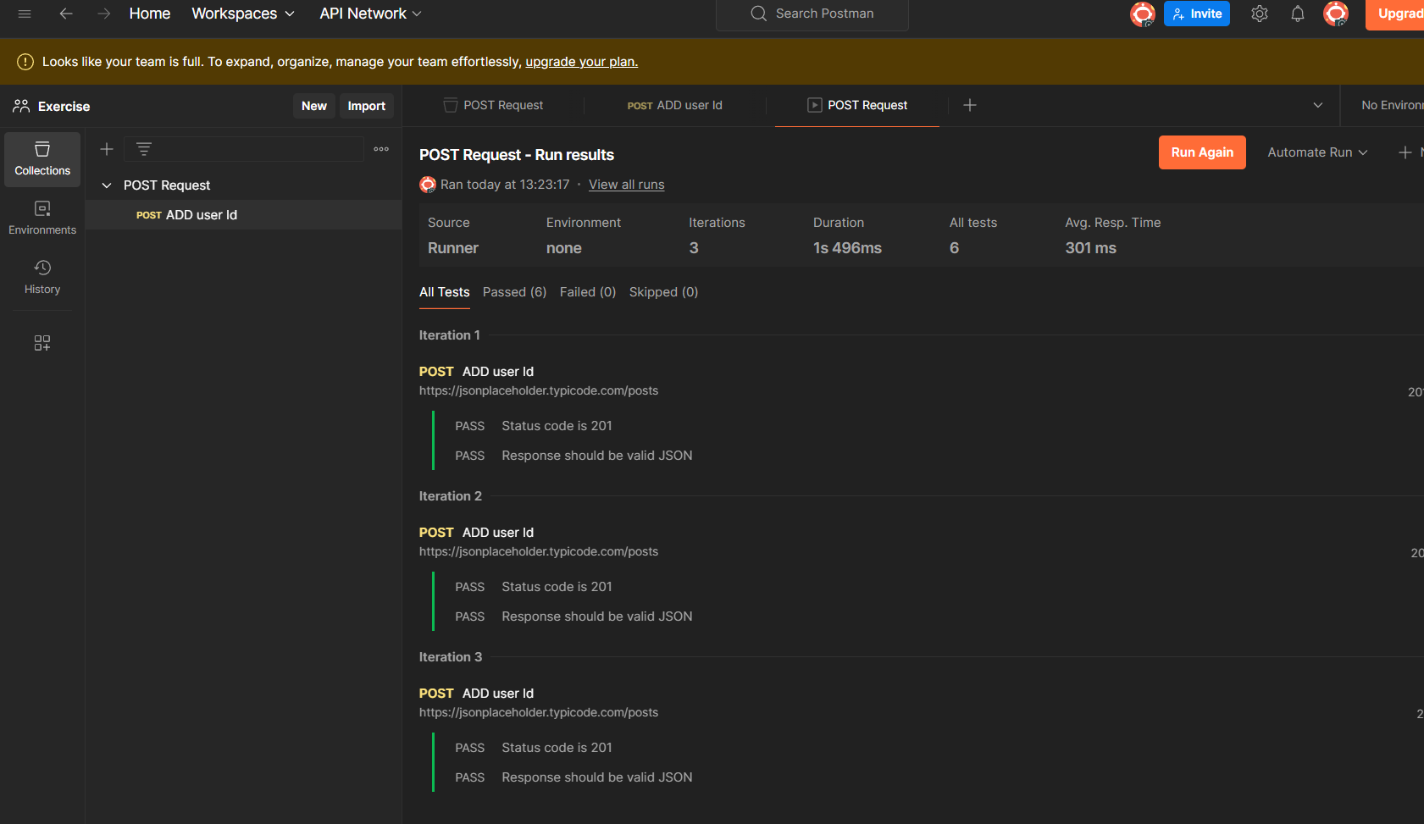

Same for the json file create a json file add data to it and select the json file and click on run to see the output

**Run collection remotely with url**

Click on collection, go to three dots and select share

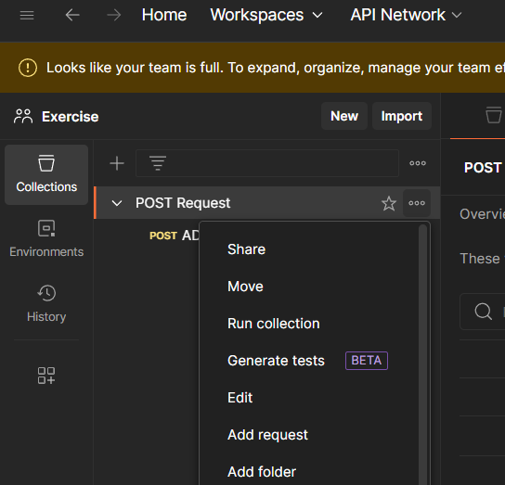

Now copy the link so that you use the url to run collection remotely on another machine

In different machine go to command prompt and run the following command

Newman run <copied url>

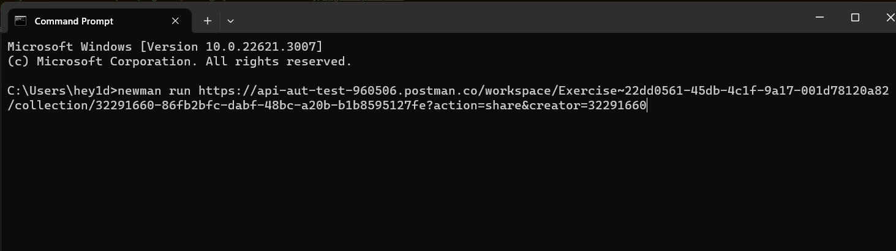

result

